

Furniture poverty and the effect on life chances.

Marion Jane Kenyon

609085

March 2022

Masters in Business Administration

Aston University Business School

BDM 154_SE06_A

Abstract

NewStarts has been providing free and affordable furniture for individuals and families in poverty for the past 16 years. People who live in poverty, are affected by that poverty in a variety of ways, one of these is the inability to afford essential household items, that those unaffected by poverty take for granted. Recently defined as furniture poverty, the effects that this particular facet of poverty has on the lives and life chances of households, has not been studied a great deal. This research seeks to add to the current body of knowledge in order to: 1. Further develop the work of NewStarts, 2. Add to the body of knowledge already available. Understanding whether lack of essential items has a negative or positive impact and whether choice or the inability to afford items, affected that impact are important in not only the development of solutions, a key part of NewStarts’ work, but also in raising awareness of the challenges faced by those living with furniture poverty.

Statement / Declaration: “I declare that I have personally prepared this report and that it has not in whole or in part been submitted for any other degree or qualification. Nor has it appeared in whole or in part in any textbook, journal or any other document previously published or produced for any purpose. The work described here is my own, carried out personally unless otherwise stated. All sources of information, including quotations, are acknowledged by means of reference, both in the final reference section, and at the point where they occur in the text.”

Signed: 

Dated: 18th March 2022

Acknowledgements

All those who have participated in the surveys and interviews and provided written statements to help me better understand the challenges faced by those in furniture poverty.

My colleagues at NewStarts, who have put up with me going on about how furniture poverty affects lives and listened to the blow by blow account of where I am; your patience and support has been immeasurable. I would especially like to thank Andy and Margaret, who originally saw the problem of furniture poverty and did something about it. Without you there would be no NewStarts, there would be no research, and I wouldn’t have a job.

My MBA cohort, who although we only met three times, have been the greatest fun, and supportive beyond belief, encouraging each other and laughing at ourselves as we have muddled through (some of us more than others).

My supervisor Prof Andy Lymer, who provided support where needed, almost gave me a heart attack by asking whether I was ready to send in my draft when I thought I had another week and provided the feedback on that draft when he finally received it.

My parents, who from an early age instilled into me that everyone has value, no one person is better than another and that everyone deserves respect.

And lastly, my husband Roger, who has supported me on this journey, who patiently read the draft, and who is somewhat nervous of my studies finishing as I have a long list of ‘things’ to do.
List of charts, tables and figures

 | Page
Table 1 - Items provided by NewStarts April 2015 to March 2020 | 14
Fig 1 - Relationship of personal beliefs and assumptions with research design and philosophy | 34
Fig 2 - Paradigms for organizational analysis | 35
Table 2 - Comparison of deduction, induction and abduction | 37
Fig 3 - Research design | 38
Table 3 – Online survey questions | 39
Table 4 – Demographics of participants in surveys and interviews | 45
Chart 1 – Online survey – ownership of essential items | 46
Chart 2 - Online survey – negative impact of lack of essential items | 48
Chart 3 – telephone survey – negative impact of lack of essential items | 49
Table 5 – Organisational characteristics | 63

Glossary of terms

Absolute Poverty after housing costs (AHC) - where someone’s household income is below a fixed line based on inflation-adjusted 2010/11 poverty line (set at 60% of median AHC in 2010/11).

Essential household items - a list of items arrived through research undertaken by the End Furniture Poverty campaign comprising of beds, bedding, mattress; table and chairs; sofa and/or armchair; wardrobe; chest of drawers; carpets; curtains or blinds; washing machine; refrigerator and freezer; cooker/oven; TV; laptop/computer.

Food Insecurity - is the state of being without reliable access to a sufficient quantity of affordable, nutritious food.

Furniture poverty – an individual, couple or household who are unable to afford to purchase all the items from the essential household items list.

Fuel poverty - in England this is defined as;

- Living in a property with an energy efficiency rating of band D, E, F or G as determined by the most up-to-date Fuel Poverty Energy efficiency Rating Methodology and
- Its disposable income (income after housing costs) would be below the poverty line (Oxley, 2021)

Contents

 |  |  | Page
Abstract |  |  | 2
Declaration |  |  | 3
Acknowledgements |  |  | 4
List of charts, tables and figures |  |  | 6
Glossary of terms |  |  | 7
Executive Summary |  |  | 10
Introduction |  |  | 12
 | Poverty |  | 13
 | NewStarts |  | 14
 | The Research |  | 17
Chapter 1 – The Literature Review |  |  | 20
 | Poverty in a historical context |  | 20
 | Forms of poverty |  | 22
 | Furniture poverty |  | 25
 | Impact on life chances for those experiencing furniture poverty |  | 29
 | Developing a strategy |  | 31
Chapter 2 – Methodology |  |  | 33
 | Introduction |  | 33
 | Philosophy & Approach |  | 34
 | Research Design |  | 38
 |  | Literature Review | 40
 |  | Surveys & Interviews | 41
 |  | Data collection | 42
 | Ethics |  | 42
 | Limitations |  | 42
Chapter 3 –Results & Findings |  |  | 44
 | Demographics |  | 44
 | Research specific findings |  | 46
Chapter 4 – Discussion |  |  | 50
 | Overall |  | 50
 | The impact on live chances, if any, of those experiencing furniture poverty |  | 51
 |  | Practical Impact | 51
 |  | Feeling safe | 53
 |  | Making a home | 54
 |  | Mental health | 54
 |  | Always negative? | 55
 | The impact on life chances, if any, of those receiving free furniture |  | 55
 |  | Practical Impact | 56
 |  | Feeling safe | 57
 |  | Making a home | 57
 |  | Mental health | 60
 |  | Overall | 60
 |  | Applied Practice | 60
Chapter 5 – Conclusion and recommendations |  |  | 66
 | Conclusions |  | 66
 | Key messages |  | 66
 | Implications |  | 67
 | Recommendations |  | 68
References |  |  | 69
Appendices |  |  | 71
 | Appendix 1 – Survey questions |  | 71
 | Appendix 2 – Online survey results |  | 78
 | Appendix 3 – Telephone survey results |  | 93
 | Appendix 4 – Transcripts for interviews |  | 96
 | Appendix 5 – Case study |  | 133

Executive Summary

The aim of the project is to identify whether the lack of essential household items has an effect on the life of an individual and if so what that effect is.

Not having and not being able to afford to purchase essential household items is one symptom of poverty. It is commonly known as furniture poverty, and has for the past 16 years been the focus of NewStarts’ work, in providing free and affordable furniture. The NewStarts strategy has been built on the assumption that the work brings benefits beyond the provision of furniture, however little research has been undertaken nationally and certainly none has been undertaken in the local area.

The information gathered by the research will be used to draw conclusions and make recommendations to the NewStarts Board of Trustees in order to develop the future strategy of NewStarts, and provide better evidence of both the need, and impact of the need, and impact of the solutions to funders.

The research gathered information from a variety of sources, which included, previous research and literature, professionals working with households in furniture poverty, NewStarts own records and those experiencing furniture poverty. The information gathered, provided a clear picture of how furniture poverty affects those living with it, much of which was supported by previous research and literature into the topic.

The conclusions from the research are:

- Furniture poverty has a negative effect on those who are affected by it. This negative impacts falls into four main areas:
  - Practical Impact
  - Feeling Safe
  - Making a home
  - Mental health

- Those experiencing furniture poverty may have complex needs that require support beyond the mere provision of furniture.

- Professionals may make decisions about how to relieve furniture poverty, and due to unconscious and/or conscious bias, do not always take into account the needs or desires of the client, leading to a client feeling pressured into agreeing to solutions that they do not understand or want.

The recommendations of this report are that:
- NewStarts develops its new strategy, underpinning the provision of free furniture with the social impact that it has on those in receipt of the furniture and the wider community
- NewStarts undertakes a review of its free furniture operations using the findings of the research to develop further pertinent questions.
- NewStarts identifies key partners and leads on a review of the support currently provided to those in furniture poverty.
- NewStarts becomes the voice for issues around furniture poverty in the West Midlands and forms a stronger link with the End Furniture Poverty Campaign

The 1834 Act gathered together provision for the poor into local Boards of guardians.
Provision was provided through the workhouse system, which housed and fed those in most need and schoold children in return for work.
Provision outside of the workhouse system was removed.

Introduction

Poverty

Poverty has long been with us and there have been many efforts throughout history, to define, to understand and to be rid of, what most consider a scourge on their community, whether local, national or global. There is no one definition of poverty, with it meaning different things to different societies, or different groups within a society. In the UK, despite a very different set of circumstances and a belief that society has developed and grown and become more tolerant, in the 21st century there is similar rhetoric around poverty being self-inflicted through laziness, poor choices, alcohol and drugs, as there was in the late 19th and early 20th century, (Glennerster, Hills, Piachaud et al 2004). This is mentioned here, not because there will be detailed discussion about the history of poverty, or the timeline, but because, that rhetoric, can and does have a bearing on the way individuals view themselves when they or others perceive them to be living in poverty, and therefore the impact that poverty has on their lives, in particular for this research the effect that lack of essential items of furniture have on their ability to lead a fulfilling life and make the most of the chances offered to them.

As the research progressed, in interviews words like stigma and shame emerged as well as fear of what the authorities might think of an individual and this was reflected in the already existing literature.

NewStarts

The response to poverty relief and prevention has traditionally been through the third sector, however, the 1834 Act, began the road from amateur to state control, which has continued with legislation after legislation, yet despite this, organisations such as NewStarts continue to provide support for those experiencing the greatest levels of poverty.

NewStarts is based in north Worcestershire and has a satellite operation in south Birmingham, which opened in 2018, providing free household items to those who cannot afford to purchase items themselves. The organization started in 2006 and became a registered charity in 2009. The organization uses an extensive network of referral agencies, over 200, ranging from local churches and schools, through to housing associations and Birmingham City Council, the largest local authority in Europe.

In the five years previous to the pandemic, April 2015 to March 2020 (numbers have decreased for the period April 2020 to December 2021 due to difficulty in collecting and delivering items), NewStarts provided the following items:

Bed,  Bedding,  Mattress | Table &  Chairs | Sofa  Armchair | Wardrobe  Chest of Drawers | Carpets | Curtains  Blinds | Washing Machine | Fridge  Freezer | Oven | TV | Computer  Laptop
795 | 394 | 1,178 | 1,649 | 485 | 755 | 146 |  |  | 15

Table 1 – items provided by NewStarts April 2019 to March 2020

These items were provided to 1,970 households. Statistics from NewStarts show that of these 1,970, 25% were homeless or in temporary housing moving into a longer term tenancy, 1,475 (75%) were existing tenants and 1,010 (51%) were considered, by the referring agency, to be on a low income (this has never been defined by NewStarts and is left to the referral agency, who understand the client they are dealing with, to decide whether the income is low). 523 (26%) of the households were considered, again by the referring agency, to be in financial crisis. Further analysis shows that 175 (9%) were to families with children and 123 (6%) were to households with people over the age of 65.

These statistics show that even in a relatively affluent area of the country there are those who struggle to provide the essential items for themselves and rely on the work of organisations like NewStarts to assist them in furnishing their property.

At its beginning the work of NewStarts was a response to an identified problem, however as the organization has grown and developed, and feedback has been received, it has been noticed that for many recipients the impact of the furniture appears to go beyond the practicality of having a bed, or a table, or a sofa, to something more. There are many anecdotal stories of the impact of the provision of a bed on the ability to attend work or school and participate more fully when there. There are also stories of tears when furniture arrives, both in thankfulness and in relief that further expense or debt is not needed. In fact, only recently, much has been made of the teacher in Leeds who has, through the Zarach project (www.zarach.org.uk, 2018), been providing beds for children and how she first identified the need.

Although we have witnessed this wider impact, there is little specific research into this aspect of the provision and whilst we use this anecdotal evidence in grant applications, or in measuring the impact of the work, there is no empirical evidence to support the assertions that are made. There are a handful of specific furniture poverty reports undertaken by the End Furniture Poverty campaign and, some wider research includes reference to furniture poverty although this can sometimes be referred to as ‘material poverty’.

The anecdotal evidence of not having a bed to sleep on is that children struggle to concentrate in school and adults struggle to concentrate at work, but are there other effects of not having other essential household items? Could the lack of curtains make an individual feel unsafe? How does a mother feel if they cannot provide for their children? Is there fear of the authorities if certain furniture items are not present? All of these questions are ones which need to be answered in order to understand the impact on families and individuals who are living in furniture poverty. An additional challenge is identification of the issue. With the reduction in home visits, which had already begun before the intervention of COVID-19, and has now become more embedded, unless a client identifies the issue to the support worker, it is likely to be missed.

The organization has just recruited a new Board of Trustees and is currently in the early stages of developing a new strategy, which requires a greater understanding of the issue of poverty more generally and the specific issue of furniture poverty and, how best to respond to that issue. Understanding the impact that a lack of items has on an individual and/or their family is important in developing appropriate responses, driven by the community that NewStarts is seeking to work with. This will allow the new Trustees to investigate whether current responses are appropriate and whether there are better responses, as well as allowing the organization to find new ways of working with current and potentially new partners in providing new innovative solutions where appropriate.

The research

The research therefore seeks to understand the following:
- What impact, if any, on their life does a lack of essential household have on a household, and
- If they have been a recipient of free household items, what impact did that provision have?

For the purposes of this research, essential items will be limited to those developed by the End Furniture Poverty Campaign. These are:
- Bed, bedding and mattress for all members of the household
- Dining table and chairs
- Sofa and/or easy chairs
- Wardrobes/drawers
- Carpets in living room and bedroom
- Curtains or blinds
- Washing machine
- Refrigerator and freezer
- Cooker/oven
- TV
- Computer/Laptop (added in 2021)

(End Furniture Poverty 2016)

The research will take place using a mixed-method approach combining surveys, online and telephone, individual interviews and pre-existing NewStarts data. Interviews and telephone surveys will be taken from those who experience lack of furniture either by choice or through lack of money and also professionals working with families and individuals who are experiencing lack of furniture due to poverty. The online questionnaire will be open to all who wish to participate and will be circulated through social media and partner organisations. The results of the interviews, surveys and NewStarts’ own historical data will be used to develop a preliminary hypothesis regarding the impact of furniture poverty on the lives of those who experience it and also the impact of the current resolution has on their lives.

The hypothesis will then be used in the review of the NewStarts governing document, the development of the new Strategy and Strategic Plan for NewStarts and in applications for grants, where the information will provide the arguments for both the ongoing and potential new innovative work.

Developing the strategy will use the generic Strategy model developed by Porter (Porter, M. 1985). The generic strategy model provides for a level of flexibility and diversity that fits with the diversity of the current work of NewStarts and the likely future work. This will allow the Board of Trustees to develop their thinking and allows flexibility in the developing of a hybrid strategy, which, with current changes in operations, may be necessary in order to maximize the impact that the organization can have within the community, alongside maximizing income in order to maintain that impact.

Underpinning the work on the strategy will also be a work in understanding the core beliefs of both staff within and without of the organization in order to understand how those beliefs align to the findings of this research and where there might be alignment and where there might be opposition to any changes in the substance of the work undertaken by NewStarts or the way in which it is undertaken. .

Chapter One - Literature Review

In order to understand furniture poverty it is important to understand the wider issue of poverty, because a lack of furniture and the effect it has on an individual’s life will be affected by the wider issues of poverty that they are likely also to be experiencing. The following literature review provides insight into general poverty, the varying types of poverty that are recognized in society today, the positioning of furniture poverty and how furniture poverty, in particular, affects the lives of those living with it.

Historical context of poverty

The concept of poverty has been around for millennia and is mentioned in ancient texts using a variety of words and definitions in much the same way as there are various ways of describing the poor and those in poverty today. In ancient Hebrew there are six words for poverty, ebvon (economically or legally distresses – destitute, a beggar); dal (poor, weak, inferior, lacking – someone struggling, such as peasant farmer); mahsor (a lack of material goods, in need of material goods); ras (politically or economically lower than ordinary people/a lazy person); ani (economically poor, oppresses, exploited and suffering); anawin (poor, but tends to be used to signify poverty and piety and is not often used). (Tenai, 2010).

As with today’s descriptions of poverty they are made up of the type of poverty and the reason behind the poverty. In early Hebrew texts there is also guidance or instruction on how to deal with poverty, in some instances the need to provide support and in others the need for the person who is in poverty to overcome their ‘laziness’ in order to rid themselves of poverty. In ancient Egyptian literature, although there is an assumption of poverty within the servant/working classes, this is not displayed openly in either literature or in the pictures that we are all familiar with. (Driaux, 2021).

Whilst it is interesting to note the length of time that the human race has lived with, and in poverty, it is only over the past 100 years that researchers have spent time developing their understanding of poverty, the causes, the types and the efficacy of remedies. The first ground-breaking piece of work identified a level of income below which a household was considered to be in poverty and undertook a survey of households in the east End of London. (Booth, C. 1888)This research was followed a few years later by Seebhom Rowntree, who having read Booths work wondered whether there was a similar situation of regarding poverty outside of London. (Rowntree, B.S. 1901) Poverty: A study of Town Life). His research found that the levels of poverty did hold outside London and furthermore, Rowntree developed a more robust poverty line and distinguished between what he referred to as primary and secondary poverty. Primary poverty was experienced by those who no matter how ‘sober’ and efficient their lifestyles were, they would not be able to afford the basics of life, whereas secondary poverty was caused by ill-spending of funds that should be spent on the essentials. His research also identified that for many households, there was insufficient funds even by the standards of the Local Government Boards for families to feed themselves properly.

Fast forward one hundred years and there is now a plethora of research on poverty, both generally and on the now-defined sub-groups of poverty, namely food, fuel, digital and data. Poverty has also become one of the group of challenges known as ‘wicked’ problems. (Rittel & Webber, 1973). In their paper ‘Dilemmas in a General Theory of Planning’, they noted that there were some problems for whom the problem could only be defined, once the solution was found. Poverty is one such problem. The causes of poverty are many and various and it is simplistic to say that low income is entirely to blame. In the same way, the signs of poverty are many and various and it is to this that we will now move.

Forms of poverty

In order to understand the positioning of furniture poverty it is important to understand the concept of poverty as it is generally defined, the various forms of poverty, the impact they have on life, where that is known, before moving into the arena of furniture poverty and what little is known about the impact, and what would be useful to know, both generally and for NewStarts specifically, as it develops a new Strategy and Strategic Plan.

There are three widely used definitions of poverty in the UK, however for the basis of this research where the term poverty is used, unless otherwise stated, the definition will be that of absolute poverty after housing costs (AHC) – where someone’s household income is below a fixed line based on inflation-adjusted 2010/11 poverty line (set at 60% of median AHC in 2010/11). (Barry et al, 2022 p.100).

The general picture in 2022 is one of families and individuals who have least having even greater difficulty in accessing the essentials that are considered necessary for a ‘normal’ life. The latest figures (Barry et al, 2022) show that 22% of the population live in poverty, 1 in 3 children live in poverty and almost 1 in 5 pensioners live in poverty. At a time when the cost of living is increasing, especially in food and fuel, the situation would appear challenging, especially for those who are on the lowest incomes, and already spend 55% of their income on housing, energy, food and clothing.

Many in the households with least money also do not have liquid savings, and are therefore not in a position to replace should they break The new Family Resources Survey, which looks at food security has identified that 1 in 5 individuals living in poverty live with food insecurity and this number is growing. Food insecurity is the inability to obtain food of sufficient quantity and/or quality to meet an individual’s basic needs. The picture is no different with energy, especially with the current rising utility costs. Fuel poverty in England is defined as:
- Living in a property with an energy efficiency rating of band D, E, F or G as determined by the most up-to-date Fuel Poverty Energy Efficiency Rating Methodology and
- Its disposable income (income after housing costs) would be below the poverty line. (Oxley, 2021)

Long-term fuel poverty has an effect on households and the individuals within those households, especially babies and children. Babies and children living in cold homes are more likely to be admitted to hospital with illness and more likely to suffer from breathing problems, there is also the issue that if children are ill, they are likely to have increased absence from school and therefore reduced education. In addition the strain of trying to deal with high energy bills, compared to level of income can cause family members stress and ongoing mental health conditions. (Guertler & Royston, 2010). However the question of how mental health is affected is difficult to ascertain.

There is an argument that poverty can cause mental health issues, and conversely that mental health issues can cause poverty issues. In fact the data held by NewStarts shows that 9% of those who receive furniture from the Organisation have a mental health issue, whilst only 6% have a physical health problem, indicating a link, for at least some individuals, between poor mental health and financial challenges.

In their paper Kromydas et al (2021) undertook research into whether money, poverty or paid work were most important to mental health. Their conclusion was that whilst income changes, alone, were not as important as might be expected, that when these were combined with movement below and above the poverty line and a change in employment status, the effect on mental health was more significant. So for these households where income may be variable, such as in the case of Universal Credit where there is employment (Universal Credit work allowances - GOV.UK (www.gov.uk) the effect on their mental health may be significant along with their ability to manage and afford utility bills and food.

The question then arises, if so many households are struggling to purchase what would, be considered essential, then how does this impact on purchasing other items such as household goods that might be considered essential. As the cost of food and duel increases, so the spending on household goods and services has decreased. (Barry et all 2022p.66) If this is the case, does it mean that households are less in need, or are they living without and if they are living without does this have any effect on their lives or the life chances?

Furniture poverty

In 2018, the End Furniture Poverty campaign undertook a piece of work, ‘The Essential Items’. (Campbell, 2017). This survey was limited in its respondents, 101 in total, and relied on professionals working in the housing, charity, universities and local authorities sectors. Interestingly, it did not include households who were recipients of the furniture provided by charities. Although, perhaps not significant, there is a possibility that the essential items that were decided on, are those considered essential by a portion of society who would expect them to be in a home, however, might not be expected where there has been a generational or cultural lack of that particular item.

The results of the survey identified a number of outcomes:1) a list of essential items, 2) reasons for there being a lack of furniture, 3) respondents didn’t feel the list wouldn’t change a great deal over the next few years and 4) the term furniture poverty was something they could support. Like the research in this piece of work, the research was undertaken locally, however there is indication in the latest Joseph Rowntree Report (Barry et al, 2022) that furniture poverty could be widespread across the nation, with only 1in 3 people who live in the poorest households, having liquid savings of more than £250. This makes it difficult to buy new items if moving into a property or to replace broken items. In addition Buttle UK reported in 2021 that they had helped 9,000 children and young people across the UK with items from the essential item list and support workers who were questioned identifying that 30% of the families they were helping needed beds. (Buttle UK, 2021)

The list of essential items in 2018 was:
- Bed, bedding and mattress
- Table and chairs
- Sofa and/or easy chairs
- Wardrobe and/or Chest of drawers
- Carpets and /or floor coverings in living rooms and bedrooms
- Curtains or blinds
- Washing machine
- Refrigerator and freezer
- Cooker/over
- TV
- Computer/Laptop (added in 2021)

The barriers to owning these essential items were, in the opinion of the respondents:
- Lack of income to purchase items, or to transport free items
- Accessibility to grants – often the criteria set are too narrow for those in need to be able to access them
- Lack of grant funding – grants are often open to organisations, but less so to individuals, especially since the move from single payments, then to social fund budgeting loans, CCG and Crisis loans, then to local authority welfare schemes.

In March 2021, the End Furniture Poverty campaign published a further piece of work ‘The Social Return on Investment Study into the Provision of Essential Household Items’. The report was commission by the FRC Group, who were created 30 years ago to enable access to furniture for those in most need. In this study the group defined furniture poverty as a continuum, that flowed from sufficient furniture of good quality in a usable condition through to those in furniture insecurity (a household with all it needs for now, but wouldn’t be able to replace something if it broke), through to furniture destitution (a household with none or very few of the basic items needed).

This piece of work aimed to provide an insight into the value, beyond the estimated value of the item, of providing one or more of the essential items to a household. This type of measuring of value is commonly known as Social Return on Investment, further details of which can be found in the Guide to Social Return on Investment (Nicholls, Lawler et al, 2009). This report accessed 25 recipients of free furniture and the interviews consisted of 10 questions.

Although the survey was undertaken in order to develop an outcomes model, rather than identifying challenges with life chances, there were some interesting responses that indicated that the provision of a piece of furniture did affect the opportunities for an individual in a household. The responses indicated a sense of pride, through phrases like ‘being able to provide for my family’ and being able to function as a normal family because they could cook their own tea. There were also financial benefits to households. Being provided with a washing machine meant less money being spent in a launderette along with not having to rely on friends and family to do washing. Interestingly some participants also mentioned social isolation as being reduced because the furniture meant that they felt more able to invite friends and family into the home. Some of these responses reflect responses NewStarts have had to their own surveys over the years, as well as case studies that have been used in grant applications.

In January 2021 the FRC published a further report that investigated why social housing is often let unfurnished and what were the obstacles to providing furnished accommodation. (Nichols, A, 2021) Like their first report, although this does not specifically deal with the issue of the impact of not having furniture on life, there are some interesting findings that help with the understanding of the impact of lack of furniture on the household. The report identifies that social renters, those who rent from either local councils or housing associations, are the most likely to be experiencing material deprivation, and also the most likely to require additional levels of support from the housing provider.

This report identified the impact of not having essential items and they very much mirror The Social Return on Investment report with individuals citing how they felt embarrassed at having to take their washing to neighbours’ houses. In addition this report noted that some provision was made for children through grants, but many grants did not cover the essentials, such as a bed for adults, and in one instance an individual who was reliant on refrigerated medication was unable to secure a fridge.

Impact on life chances for those in furniture poverty

As has been noted previously there appear to be a number of impacts on life and opportunities if a household is lacking essential household items. These impacts include embarrassment, social isolation, sleep deprivation and in at least one instance the inability to store essential medication. All of these experiences are ones which NewStarts, has anecdotal evidence of within its own records. The difficulty is that all the research undertaken on furniture poverty to date, and there has been little, has been directed at answering questions, which whilst related to the impact on life chances, do not directly ask or answer that question.

Clearly there are a number of impacts that not having furniture can have, perhaps the most significant and most obvious, being the difficulty in maintaining a tenancy if one does not have items with which to furnish a property. The options open to individuals are few, and often involve taking on debt or living without. In 1997 22% of tenants interviewed identified that maintaining a tenancy would be difficult if they had to purchase furniture. (Rooney, B. 1997)

A longitudinal study of 400 households over three years undertaken by Warmes et al. 2013 did not show a link between tenancy termination and lack of furniture, however Pawson et al. 2006 showed that early tenancy termination in unfurnished properties, was twice that in furnished properties and in this study lack of furniture featured highly in the reasons for termination, along with anti-social behaviour by neighbours, debt problems and inability to manage money and social isolation. As the Homelessness Task Force (2002) stated "for many homeless people, the offer of an unfurnished tenancy is not enough because they lack the means to provide basic furniture. In these circumstances, the tenancy is unlikely to be viable or sustainable".

Clearly then for a household moving from homelessness into tenancy, 25% in the case of NewStarts, there is a significant risk that they will be unable to maintain their tenancy in the short-term, if no furniture is provided, and that this will lead to a cycle of homelessness – tenancy- homelessness.

NewStarts own experience and that of the charity Zarach, in Leeds, identify the perception that children without beds, or who sleep in broken beds, do not achieve as much at school and consequently have their life chances affected. However, similarly to the early tenancy termination, the effect has only been measured in the short-term and it would need some longitudinal studies to identify whether after the initial positive impact has settled, whether attendance, behaviour and concentration remained at the initial levels or whether they deteriorate after a period of time.

It is evident that whilst there is some literature on the effect of furniture poverty on life chances, it has often been the result of research or policy development in another area such as developing the argument for providing furnished social housing or as part of the research for measuring the social impact, or mentioned in passing as part of the more general analysis of poverty overall. The fact that the literature available has not been produced in direct answer to the research question of this research, does beg the question as to whether the research is needed.

Firstly it may be that the reason there is no in-depth research into this question is because there ‘is nothing to see here’, or in more formal terms although there is an implication that lack of furniture effects people’s lives, it is no so great a problem that it needs research or that there needs to be a solution or solutions proposed to the problem. However, the evidence across a number of pieces of research including Barry et al 2022, The Homelessness Task Force 2002, Campbell 2017, Nicols 2021 and Nichols 2009 would suggest that there is a significant challenge faced by those who experience furniture poverty and that this type of poverty does in fact effect their lives and the opportunities they may be able to access.

Developing a Strategy

The purpose of this work is to enable the NewStarts organisation to develop a new Strategy that will encourage flexibility and a high level of responsiveness to often changing situations. The previous strategy finishes in 2023 and has been severely disrupted due to COVID-19 and this along with the arrival of a new Board of Trustees makes this an opportune time to begin the work.

In developing the strategy NewStarts will use the information from this research along with financial and other known data to identify which of the Generic strategies would support their work. (Porter, M. 1985). The generic strategies encompass three types of strategy, one of which is further subdivided into two categories. The strategies are Cost Leadership strategy, which involves ensuring that the organisation is the lowest costing organisation – our free furniture and furniture sales might fall into this category, Differentiation strategy – offering a unique activity or service that allows premium price (or in the case of NewStarts furniture this might be free, but allows maximum grant funding). These two aspects allow for a wide breadth of target.

The third strategy is Focus strategy and this focuses on a narrow sphere of activity and is very much about tailoring its products. The Focus strategy is further divided into cost focusers and differentiation focusers. The former is focuses on a specific type of product that is sold at a low price, whereas differentiation focusers, engage with a specific need. This generic strategy development model is likely to provide the flexibility that NewStarts needs in developing its strategy because of the wide range of activities that it participates in and the wide range of stakeholders that are either consumers or funders of these activities.

The organisation will be using a cultural web approach to underpin the development of the strategy. (Whittington, R et al, 2020). This approach enables an organisation to identify the core beliefs of individuals within the organisation, how they affect the core beliefs of the organisation and how that is then displayed in various aspects of the organisation, which in turn will support the implementation of the new strategy and any new ways of working.

Chapter 2 - Methodology
Introduction
From my own experience, the experience of NewStarts and other similar organisations and some limited pre-reading there appeared to be a linking between the inability to afford furniture and the life chances of a person in such a situation, but on the surface it appeared that there was little direct research into the question. However, there was significant research into the wider topic of poverty and the now well-known sub-sets of poverty (food, fuel, data and digital) and the effect they appear to have on the life chances of individuals, especially children.

Because poverty can be an emotive subject it was important that firstly I recognised the need to reflect on my own beliefs and assumptions in order to identify the most appropriate research philosophies and designs for the piece of work. This reflection on my own beliefs and assumptions was returned to a number of times throughout the research, using the model in Fig 1 in order to ensure that I wasn’t 1) seeing results I wanted to see in order to further the work of NewStarts and 2) seeking results that would use the solutions I felt best would resolve the issue of furniture poverty and its effects, if that indeed was the result of the research.

Beliefs and assumptions
Research design
Research philosophies
Fig 1 - Source: Alexander Bristow and Mark Saunders
Philosophy and Approach
The philosophies for research fall under two broad areas, objectivism and subjectivism. (Burrell and Morgan 2016) The individuals and families that find themselves in furniture poverty can, and often are viewed as having failed in a world that is for the most part constant and predictable (objectivism), however for many, the world is complex and full of interactions, some of which they have no control over and they each experience that world in different ways with different perspectives, trying to adapt as best they can (subjectivism). Often those placed in positions of power such as local government and charities who are providing solutions are found in the objectivism group, whilst those experiencing a challenge and those working very closely with them, will see the challenge from a subjectivism perspective.

Importantly alongside these two philosophies are the research paradigms of regulation and radical change. In developing the research method, understanding how the philosophies and paradigms interacted I used the matrix developed by Burrell and Morgan, Fig 2, in their book Sociological Paradigms and Organisational Analysis (2016) which combines objectivist-subjectivist continuum with the regulation- radical change continuum. In using this model it became easier to see how the continuums interact, although Burrell and Morgan held that due to the definitions there is no interaction.

Radical Change
Subjectivist
Objectivist
Radical humanist | Radical structuralist
Interpretive | Functionalist

Regulation

Fig 2.paradigms for organisational analysis
Source: Developed from Burrell and Morgan (2016) Social Paradigms and Organisational Analysis (Saunders et al 2019)

The research and particularly the use of the research findings fall somewhere along the continuum of the interpretive paradigm and radical humanist paradigm. These two paradigms provide, in the case of interpretive, a way of understanding the world around us and understanding the cause and effects of actions and in the case of the radical humanist paradigm, a way of investigating how power, domination and oppression can be overcome using social construction, language and processes.

Using the above as background I then selected the interpretive and postmodernism management philosophies, to drive the way in which information would be gathered in order to develop a theory in considering the methodology for not only the research, but also how that will be applied to the development of a theory that can be used to underpin the new Strategy. Importantly for this piece of work post-modern management theory questions how things have been done in the past and allows those who are normally considered to be on the margins the opportunity to participate in the development of a piece of work. In this instance, both those on the receiving end of NewStarts provision, those in furniture poverty, and those who work for NewStarts will be able to participate in the development of the new strategy.

There are three approaches; deduction; induction; abduction.
Table 1, taken from Research Methods for Business Students (2019) shows a comparison of the three approaches.
 | Deduction | Induction | Abduction
Logic | In a deductive inference, when the premises are true, the conclusion must also be true | In an induction inference, known premises are used to generate untested conclusions | In an abduction inference, known premises are used to generate testable conclusions
Generalisability | Generalising from the general to the specific | Generalising from the specific to the general | Generalising from the interactions between the specific and the general
Use of date | Data collection is used to evaluate propositions or hypotheses related to an existing theory | Data collection is used to explore a phenomenon, identify themes and patterns and create a conceptual framework | Data collection is used to explore a phenomenon, identify themes and patterns, locate these in a conceptual framework and test this through subsequent data collection and so forth
Theory | Theory falsification or verification | Theory generation and building | Theory generation or modification incorporating existing theory where appropriate, to build new theory or modify existing theory.
Table 2 – comparison of deduction, induction and abduction
Comparing the three approaches to theory development, abduction provides flexibility of the use of data to influence theory development in an iterative manner, which will allow for new and interesting information to come forward and be tested, and if not fully completed in this research could be the basis for further research.

Using the research philosophies outlined above the research was undertaken using a mixed method approach combining both qualitative and quantitative date (Tashakkori & Teddle 2012). This approach aimed to ensure diversity in the data being collated. It is important for the strategy that not only is there quantitative data around the extent of the challenge of furniture poverty, facing the organisation, but also what effect the lack of furniture has on individuals and the effect that provision of that furniture has. Initially the intention was to use a range of techniques including online and in-person surveys, one-to-one interviews, focus groups and case studies, however time constraints and lack of enthusiasm for focus groups, meant that these were dropped from the research at an early stage.

Research Design
The design for the research used a traditional management programme/project approach laid out in fig 3

Interviews
Research questions
Conclusions & recommend-
ations
‘surprising fact’
Literature review
Analysis
Survey
Findings

Fig 3 – research design

With the purpose of engaging as many individuals, both lived experience and professionals an online survey was developed and distributed through email lists and social media. In addition to the online survey, emails were sent to all NewStarts partner organisations encouraging participation in 1:1 interviews and focus groups.

The full online survey question set is attached at appendix 1, however the main questions linked to the research question are shown in Table 3:

Survey/interview questions

Below are a list of items considered essential. Which of them do you own?

Bed, bedding, mattress for everyone in the household

Washing machine

Dining table and chairs

Oven Cooker

Fridge and/or freezer

Sofa and/or armchairs

Wardrobe

Chest of Drawers

Carpets

Curtains

TV

Laptop/computer

If there are items you don’t own is this through choice or lack of money?

Thinking about the items you cannot afford to own, does the lack of these items affect you in a negative way, and if so, how?

Thinking about the items you cannot afford to own, does the lack of these item affect the lives of other members of your household in a negative way, and if so, how?

Thinking about the items you cannot afford to own, does the lack of these items affect your life in a positive way, and if so, how?

Have you ever received household items from NewStarts or a similar project?

If you have received free items, what impact did it have on you?

If you have received free items, what impact did it have on others in your household?

If you would like to add any further comments please add in the box below.
Table 3 Online survey questions

The questions were tested on a number of individuals and this led, to some being amended to make them simpler to understand. The same questions were also used in the 1:1 telephone interviews, with recipients of NewStarts furniture. There were also three 1:1 follow-up interviews that took place that were unstructured and developed the answers to the online survey and the reasons for those answers being supplied. The online survey was available for completion from 22nd January 2022 to 20th February 2022 and all telephone and 1:1 interviews were also completed during that time.

Literature Review
The literature review was undertaken in two stages.
Stage One
Initial searches in both the Aston University library and google scholar, realised very little in the way of literature on furniture poverty, however there was considerable information on poverty in general and other aspects of poverty such as fuel and food. I was aware of some research undertaken by the End Furniture Poverty Campaign and used that along with the general poverty literature to develop a more complete understanding of the context in which furniture poverty exists.

Second stage
Using references cited in documents on the primary reading list, including those reports produced by the End Furniture Poverty Campaign, I was able to build a much more comprehensive list of literature that either examined furniture/material poverty or at least mentioned it. Interestingly, a number of the references were books rather than papers and this limited the usefulness due to the length of the books and time constraints.
The information was gathered from the various sources and from this a picture of poverty through history was developed, more recent research and then focus on the sub-set of furniture poverty, a picture of what furniture poverty is and how it affects lives and what the cost might be to society. There were also a number of solutions proposed within the literature. The information gained from the literature review was used to hone discussions during 1:1 interviews.

Surveys and interviews
The online responses were received over a four week period and a majority were received from professionals working with those in furniture poverty. These responses were self-selecting to a large degree, although information was distributed through known partner networks, as well as Social Media (Results Appendix 2).

The research also involved speaking to five households who had been recipients of free furniture from NewStarts. These were selected randomly. Every tenth client was selected using an anonymised database. The record number from the database was used to identify the household. These individuals were contacted by phone and asked whether they were happy to participate after the research had been explained to them. Results for these interviews can be found in Appendix 3.

On completion of the survey a number of individuals, indicated that they were happy to be interviewed either in person, or via video technology, three were interviewed on a one-to-one basis. These individuals all self-selected to take part in the more in-depth interview. Transcripts for these interviews can be found in Appendix 4.
Lastly, the research reviewed case studies, with one found that was particularly relevant and this can be found in Appendix 5

Information from the questionnaire was analysed using excel (a more complicated database was not deemed necessary due low numbers) and provided quantitative as well as qualitative data.

Data collection
The data was gathered together and divided into quantitative and qualitative data, as well as professional and lived experience.

Ethics
Many of those who experience furniture poverty also experience trauma and other forms of poverty, and this can cause flashbacks and stress when they find themselves having to explain the circumstances of their need, therefore the emphasis was always on the furniture poverty issue rather than the cause. In addition although children are often affected by furniture poverty, possibly in different ways to adults, no children were involved in the research.

Limitations
The research is on a very small scale, with 35 respondents in total and over a short time period. However much of the furniture poverty specific research already undertaken is also limited in numbers. Most of the respondents lived in the West Midlands and this too may have impacted responses, with the West Midlands being the only area of the country where poverty has increased over the past 20 years. (Barry, A. 2022)

The research being cross-sectional rather than longitudinal cannot answer questions concerning whether the provision of a bed, which has been identified as providing benefit in the short-term, continues to provide that benefit over a long period. It should also be noted that the online survey attracted more professionals than lived-experience and that lived-experience are selected from a pool known to the organisation. This could influence individuals to a more favourable response in how much benefit the relief of furniture poverty has brought, conversely for some it may have the opposite effect, if they felt they didn’t receive all the items they needed, or they felt the items were of a low quality.

The income bands for households were in line with current UK tax bands, however they should have been divided into smaller bands, including one that finished at the poverty line.

The Case study was written by staff and for the purpose, of sharing good news stories with funders and the general public who support us and so may not represent the full breadth of the experience, although anecdotal evidence has also been used which shows a slightly different slant on the provision of furniture to those in furniture poverty.

Chapter 3 - Results/Findings

The results and findings are subdivided as follows:
- Demographics
- Research specific information

Demographics

Online survey

Family life

Of those who responded to the online survey by far the majority, 83%, were female, 40% had children over the age of 18 living with them, 40% had children under the age of 5 and 32% had no children at all. 59% of respondents were in a relationship.

Income & housing

Half, 50%, owned their own property, 50% rented property, with one of those being in temporary accommodation, and 45% had an income between £12,750 and £52,270, 28%, and just over one quarter had income below £12,750.

Ethnicity

All respondents to the online survey were white British and therefore additional cultural challenges, effects or implications will not be represented in this survey.

Telephone survey

Family life

75% were female, 50% have children under the age of 16 living with them, none have older children and 50% have no children at all. 50% of respondents are in a relationship.

Income & housing

All telephone respondents are on benefits, but unable to say what their income level is and all live in rented accommodation.

Race

75% of the respondents were white British, with the remaining 25% Pakistani.

The summary of the demographics is in table 4

Demographic results from surveys and interviews

 |  |  | Online Survey | Telephone Survey |  | 1:1 Interview (taken from online survey
No of Participants |  |  | 30 | 5 |  | 3
Gender | M |  | 5 | 1 |  | 0
Gender | F |  | 25 | 4 |  | 3
Gender | O |  | 0 | 0 |  | 0
Age | <17 |  | 0 | 0 |  | 0
Age | 18-25 |  | 1 | 2 |  | 0
Age | 26-40 |  | 8 | 0 |  | 0
Age | 41-50 |  | 6 | 2 |  | 0
Age | 51-65 |  | 15 | 1 |  | 3
Age | 65+ |  | 0 | 0 |  | 0
Ethnicity | White/White British |  | 30 | 3 |  | 3
Ethnicity | Black/Black British |  | 0 | 0 |  | 0
Ethnicity | Asian/Asian British |  | 0 | 2 |  | 0
Ethnicity | Mixed Race |  | 0 | 0 |  | 0
Ethnicity | Other |  | 0 | 0 |  | 0
Ethnicity | Rather not say |  | 0 | 0 |  | 0
Relationship Status |  | Married | 10 |  | 1
 |  | Widowed | 1 |  | 0
 |  | Divorced | 4 |  |  |  | 2
 |  | Separated | 2
 |  | Civil Union | 4
 |  | Single-cohabiting | 3 |  | 1 |  | 1
 |  | Single never married | 5 |  | 3

Table 4

Research specific information

Who owned what?

Online survey

Only one of the essential items, fridge/freezer is owned by all respondents, although a number of items are supplied by landlords. However, with the exception of beds, bedding and mattresses, which did reach 100% with the landlord intervention, the ownership of the remaining items remains below 100%. Just under half of the respondents, 46% stated that this was because they could not afford the items. The least owned items were wardrobes and carpets. Results are shown in Chart 1.

Chart 1 – Surveys responses on ownership of essential items

Telephone survey

These respondents had all been provided with items from NewStarts, and so whilst they now owned them, previous to the referral 100% did not have sufficient beds for the household (in fact one still requires further beds), 75% needed a sofa and/or armchairs, 75% needed wardrobes, 75% needed chests of drawers and 50% needed carpets. All of these when asked stated that they had not been able to afford them.

Effect on life chances

The feedback on this was in the form of comments which have been analysed and responses grouped together under one or more of the headings. The headings for this analysis are: Quality of life; Practicalities; Mental Health; Safety; Making a home. Although only five respondents provided detailed responses, one commented on a number of people they had supported in their role and provided a total of four additional examples of the effect of furniture poverty, so there were in fact a total of eight comments/examples.

Online survey

All of the respondents that commented on the negative effect of furniture poverty on theirs/clients lives, agreed that quality of life was affected in some manner. 56% of the respondents indicated that there were practical impacts on theirs/others’ lives; a third, 33%, said there was an effect on mental health; 22% said that how safe they felt in the property was affected and finally 33% indicated that once they had the items the property felt more like home. Overall 89% of those who commented noted that there was an effect on the quality of life in general. (Chart 2)

Chart 2 – Online survey responses regarding negative impact of lack of furniture on aspects of life

Telephone survey

Respondents to the telephone survey differed slightly in their responses. In this instance only three, 75% mentioned quality of life, however all of them mentioned the practical impact. Only one of the respondents mentioned the impact on mental health, making the property a home. Another mentioned the fact that without the furniture she was fearful of losing her tenancy and that it was a relief when she got the items and she felt safer in the tenancy.

Chart 3 – Telephone survey responses regarding negative impact of lack of furniture on life

Interviews

In all, three interviews were completed. All three interviewees were female and had all completed the online survey in the first instance. All three worked with individuals who faced furniture poverty, although one had also experienced furniture poverty themselves. In addition those interviewed had all completed the online survey and therefore I have only listed additional points in the results:

In two of the interviews, a discussion occurred around the readiness of those without furniture through lack of funds, to be able to utilize the furniture or goods once they arrived. This will be expanded on more fully in the discussion.

In one interview, the interviewee, who themselves had experienced furniture poverty and still does to some extent, expressed the ability to be creative with furniture gifted to them. The importance of this is again, expanded on further in the discussion.

Chapter 4 - Discussion

The discussion will focus on analyzing the results of the online and telephone surveys, interviews, NewStarts own data and case studies alongside the findings of the literature review to understand answer the research question:

Does furniture poverty (the inability to afford essential household items) affect the life chances of an individual?

This question was broken down in to two further questions:

- What impact, if any, on their life does a lack of essential household items have on a household? and
- If they have been a recipient of free household items, what impact did that provision have?

Overall findings

Overall the findings of the primary research supported and were supported by the findings of the literature review:
- Furniture poverty does have a negative impact on lives
- Providing items to those in furniture poverty has a positive impact on the lives of the recipients.

There was also a number of other findings
- Lack of essential furniture items does not always have a negative impact on lives.
- The re-use of items provides a creative outlet
- Generational and cultural influences can play a part in the level of impact that furniture poverty and the resolution of furniture poverty on an household
- Not all those in furniture poverty are in rented, social or private, accommodation.

The impact, if any, of not having essential items

The literature review clearly showed that there was a negative impact on lives for individuals who were experiencing furniture poverty. This research clearly supported that hypothesis. Both individuals who participated in the telephone interviews and some of those who responded to the online survey, noted that they experienced negative impacts ranging from lack of sleep to feeling unsafe in their property. This is noted in the ‘The Return on Social Investment Study into the Provision of Essential Household Items’ (Nicholls, J., 2021) and the previous report (Nicols, A., 2021) which investigated the possibility of providing furnished properties. The negative impacts highlighted both in the literature and in the research are discussed below. In order to bring focus on the impact they are discussed under four headings:

Practical implications

Without the essential furniture items it can be difficult to organize a home. Without wardrobes and chests of drawers where do you keep clothing? For many, both in the literature review (Nicholls, J., 2021 p12) and for one respondent of this research the answer is to keep clothing in black bags (Appendix 3). This makes finding items for wearing difficult and in the morning rush of getting ready for school, creates difficulties for a mother and her autistic child. Creating additional stresses in an already difficult circumstance which leads to the child going to school in a bad mood and the mum feeling frazzled.

Not having a washing machine means trips to the launderette, which can only be undertaken when money allows, or asking friends if you can use their facilities, (Nicols, A 2021. P.38) again this was noted in the third interview (Appendix 3). Haphazard washing of clothes can also lead to a level of chaotic living and a feeling of being out of control, as well as social isolation due to lack of cleanliness both in school and the workplace.

In the literature one mum referred to her children being viewed as ‘feral’ whilst another respondent was concerned about the ability to maintain employment if they were not clean. (Nichols, A., 2021 p.32-33)

Providing space and equipment facilities for studying is impossible if the essential items in a home are not present. Lack of IT equipment can be detrimental to a child if they are unable to complete homework and even if the school provide equipment or no equipment is provided, the space to complete studies is a challenge if there is nowhere to sit and/or a table to sit at, or indeed no access to the internet. All of this leading to difficulty in completing homework and preparing, in the case of older children, for exams.

Sleeping well is one of the fundamental requirements for a healthy body and mind. Proper rest provides opportunity for both to heal and restore. Without beds this becomes difficult and whilst in many cultures sleeping on the floor is accepted, this always incurs some form of ‘mattress’, so at a very basic form the need for a mattress is essential. The lack of beds both in the literature and in this research leads to tiredness, lack of attentiveness and concentration both within school and work (Appendix 3), but also in other aspects of lives, including interactions with family members and friends.

Feeling safe

We all like to feel safe in our homes, however the lack of essential furniture items, for some, can make them feel unsafe and this seems to be for two particular reasons, both of which were noted in the research and in the literature. (Nichols, A., 2021 p.46)

The first is that without essential furniture items, individuals feel that their tenancy might be at risk. This is because they are under the impression, rightly or wrongly, that to maintain their tenancy they need to furnish the property. Without furniture their belief is that the landlord can terminate the tenancy, even when the tenancy is with a social landlord. This leads to the tenant feeling extremely vulnerable (Appendix 3). This may explain the phenomenon within the literature of lack of essential furniture items leading to tenancy termination in the short term, whereas in the longer term it does not. Is it because landlords end the tenancy, or tenants who terminate the tenancy because they are fearful of fit being terminated?

A second reason for feeling unsafe is the inability to protect the property from those outside looking in, due to the lack of one particular essential item curtains/blinds. The ability to be able to secure your home and hide it from the outside world is important to some.

Making home

Being able to call somewhere home is more than just having four walls. A sense of having somewhere you can invite friends and family to, a space that is yours and you feel safe in are all represented in the literature and borne out by our own research, through Interview three and telephone survey 2. (appendix 3), (Nichols, A., 2021 pp31,32) Both of these individuals identified either their own embarrassment at inviting friends and family into their house or the embarrassment of their children. In the case of interview 3 this not only included the lack of furniture, but also the state of decoration of the property. The lack of essential furniture items leaves the space that you live in, just that, a space without meaning.

Mental health

What clearly comes across in both the literature review and the research is that all of the individual negative impacts of living without essential furniture items, have an impact on individuals’ mental health. These include the stress of having additional costs such as launderette and take-aways, trying to organize a home without anything to organize it with, lack of sleep, fractious children, social isolation and fear and for some the extreme of suicidal thoughts. (Nichols, A., 2021 p.30)

However it is also clear from the literature review that income and working and proximity to the poverty line can also have a negative effect on mental health. (Kronydas, T., 2021) It is therefore difficult to ascertain whether the negative feelings that individuals expressed are purely as the result of furniture poverty or whether they are a more general response to the wider challenges they find themselves in.

Always negative?

Although the literature review and the research showed that there is indeed a negative impact on life for those living without essential furniture items, this was not always the case. For some the need to live without some items did not create a major problem and one interviewee cited the fact that they only ever purchased second-hand (except for beds) and that they enjoyed the creative process of making the item theirs. (Appendix 4) In fact for the research, it was only the case for those who could not afford the items, and even then not all those who could not afford the items expressed the view that there was negative impact. This might then beg the question as to what causes the negative impact.

Previous research, (Kromydas, T. et al 2021) identified that poverty of itself does not always cause a negative response, nor poor mental health. If that is the case then the impact on a household of furniture poverty might be part of a wider group of influences on an individuals’ life that cause a negative response. One possible explanation might be that of societal and peer pressure to own certain items, even if there is no desire or need felt within that household. This is further explored in the section regarding the impact of receiving items has on a household.

The impact on life chances, if any, does providing free essential furniture items have?

The literature review, again showed that there was a positive impact on people’s lives if they received free essential furniture items, indeed it is the premise for the argument that all social housing should be provided furnished (Nichols, A. 20201) (Ambrose, A. et al 2016) The research and literature review also showed that for the most part the provision of free essential furniture items improved the lives of those receiving them.(Appendix 3) A sense of being able to live as a ‘normal’ was found in both and even the most basic activities such as dressing your child, cooking tea and doing the washing were all cited as great steps forwards by households who received furniture either free or through grant schemes.

However, there was an interesting conversation in all three of the interviews around the preparedness of those receiving the items and their ability to use the items appropriately. (Appendix 4) This preparedness seemed to vary and whilst a majority of respondents are both grateful and able to use the items provided for them, there may be a significant minority that are not.

Practical effects

The practical effects are those that relieve the negative practical impact. Being able to do your washing in your own home, something many of us take for granted, is seen as a really positive benefit by someone, especially someone who has to do a lot of additional washing due a condition within the family. It also means that there are no more trips to the launderette, or seeking help from friends and family. (Nichols, A., 2021)

Similarly the mother who was struggling in the morning to get her autistic child dressed, once provided with a wardrobe and chest of drawers, expressed how she was able to organize the clothes and the reduced tension in the morning because ‘she knew where everything was’. (Appendix 3)

Having somewhere comfortable to sleep was considered a positive in the literature review and in the research, especially for the parent of a child with autism, who struggled with the disruption to what little sleep patterns they had. (Appendix 3)(End Funiture Poverty Study into Furniture Provision 2021) The effect of having a bed and/or mattress is widely reported, however there should be caution and that is around the long-term effect on behavior of having a bed. Does the provision of a bed improve the behavior and performance of adults and children or is it a short-lived effect that reverts back to the pre-existing challenges after a period of time, especially in a home, where there may be other forces at play and a level of chaos. Currently there is no research into the long-term impact of being provided with a bed, especially in the case of children.

Feeling safe

Once individuals receive free essential furniture items and can furnish their property they feel safe, because they believe they are fulfilling the terms of their tenancy. That the possession of the items means that they can no longer be evicted for not looking after the property, obviously this only applies to those in social housing. In addition for those who are able to provide window dressing, they are able to secure their homes against the prying eyes of others and this adds to their sense of security.

Making home

Those who are recipients of the furniture both in the literature review and in the research acknowledged that the provision of free furniture made the property feel more like home and this made them feel more positive about the future. (End Funiture Poverty Study into Furniture Provision 2021) (Nichols, A., 2021 p32) A positive mindset that now they had their home sorted, they could look to other things. However, what was interesting in the research and was not previously noted in the literature was the view of some professionals that some of the individuals who were provided with free essential household items were unable to use those items to good effect. In the interview discussions this seemed to develop into three distinct streams of thought:
- A difference in priorities that meant that regardless of what an individual was given in the way of free essential furniture items, it was unlikely to improve their circumstances. Priorities cited as being important in this instance were personal grooming, clothing and footwear and substance abuse taking precedence over household items or even food. This resonates with the experience of NewStarts, when we have been aware of food provision being sold to raise funds for other uses.

It therefore seemed likely that even if provided with the items, the positive impact would be negligible and that the priorities within their lives would remain the same. In addition it may be that furniture provided, if not desired or not deemed as essential, within that household may be sold in order to fund priorities. This is clearly seen in the case study one, where an individual with a chaotic lifestyle has moved from homelessness to tenancy to homelessness, with partners and without partners, with care for children and without. (Appendix 5). The progress of this particular case study is measured in years and therefore requires long-term commitment to those supporting them.
- The lack of experience, either culturally or generationally of using an item, meant that if provided with the item the individual would not know what to do with the item. This was not something that had been previously considered and could result from the decision about what constitutes essential items, being a conversation with mostly professionals and those who own all the items listed and would therefore consider them essential. This type of phenomenon has been previously identified in charity work when the provision is made without understanding, then the ability for individuals and recipients of the provision can find that the ability to act is reduced. (Lupton, R., p3)

However if from a cultural perspective, or if over the generations, your family has never owned an item, there is a distinct likelihood that its use would not be obvious and therefore it would bring no positive impact in your life or that of others in the household.
- The desire to fulfil the expectations of professionals who are working with you, or the expectations, as perceived through the media (including social media) of the general public. Those who are being supported by professionals, such as social workers, often feel the need to agree to whatever is being suggested, even if their personal preference is for a minimalist setting, because they think that is what is needed in order for them to placate the authorities and removed perceived threats, for the women in the literature review previously mentioned, this was clearly the case. (Nichols, A., p.32)

For some a similar relationship exists with the media and social media in particular, although in this instance it is an exaggerated version of ‘keeping up with the Jones’. Similar to the previous point, when provided with items, if there is no knowledge of how to use and item then there is no benefit and the improvement to life chances is not realized.

These findings, in particular could have an impact on the way in which NewStarts provides its support. Currently households are referred by an agency, this could be one area where a professional is making decisions on behalf of a client, and once received, items of furniture are selected by members of NewStarts’ staff, a second area where professionals are making decision.

Mental Health

Being able to organize a home, sleep well and feel safe all contribute to a more positive state of mind. For some the simple provision will mean that they can think more positively about the future and the anxiety and stress caused by the lack of furniture can be a thing of the past. However, there may an opposite effect, although this was not specifically identified either in this research or previous research that by furnishing a home with unrequired items, stress may increase.

Overall

The results of both the literature review and of the research support the ongoing work of NewStarts. The emphasis on the benefits that are provided through the provision of free furniture are clear. Being able to take on a tenancy without additional costs, being able to call a property a home and being able to organize that home are all essential to a majority of those who are living with furniture poverty.

Applied Practice

The research and literature provide absolute support for the work of NewStarts at its most basic. Having the information and references available and being able to not only verbalize the issues, but also the impacts and new challenges that the research has identified is a major step forward for the organization.

Developing the new strategy, whilst still a challenge because of the diversified work that is undertaken within the organization, will be underpinned by evidence that hitherto has not been available to the Trustees. As previously mentioned the intended approach will be to use Porters Generic Strategy and there are two specific parts of the Generis strategy that will be used in the development of the free furniture aspect of NewStarts’ work.

The generic strategy model has four distinct areas of strategy, which might imply that the free furniture provision would sit in one of them, however there are two sets of stakeholders for this area of work and their different direction of engagement means that the strategy developed for each of them will be developed using a different approach.

Firstly, the strategy towards the referral agencies and those who receive free furniture, will use the cost-leadership approach. This approach works towards providing goods and services at the lowest possible cost, and there is no lower cost than free. The research has shown that this is invaluable and therefore should form part of the strategy. However in order to facilitate this low-cost approach, the input costs (the costs that the organization has to bear) also have to be at the lowest level in order to make a profit, or in the case of a charity to either break-even or have a surplus.

The major costs for the organization are property, staff and transport. As a poverty prevention charity and Real Living Wage employer there is an expectation that NewStarts should do all it can to prevent poverty amongst its own staff, so reducing costs in this area is unlikely. The requirement for buildings and transport is of course essential in order to collect, store and deliver furniture. So, we come to the question, other than finding the cheapest buildings and the most fuel efficient vans, and routes, how can the organization offset these costs in order to pursue the cost-leadership strategy? In addition, in developing this part of the strategy, NewStarts needs to understand more about how clients feel in this process and what, if any, changes need to be made to the processes to ensure that at least some if not all the power balance shifts from those referring and providing, back to the end-user. This is particularly important for a Christian organization, where sometimes the emphasis can be on ‘us as the saviour’.

The second group of stakeholders for the provision of free furniture are the funders, whether they are government (central or local), trusts or donors (individual or corporate). Their interest is in the uniqueness of the work that NewStarts undertakes and the effect it has on society, which is much more in line with the differentiation approach. And whilst this approach normally applies to premium price, in this instance the approach fits because the stakeholders affected will be looking for:

- Uniqueness
- A relationship between NewStarts and themselves, that allows them to know what is happening, what work is developing and possibly in some instances to have input to the direction of the work
- Complimentary linkages to other work undertaken by NewStarts – this might include opportunities to volunteer and make a more direct difference themselves. (Whittington, R. et al 2020)

The premium price will be in the form of grants and donations (cash and items) and the ‘goods’ received in respect of the premium price will be the impact on individuals and society more generally.

In addition to the free furniture element of the work the Trustees will also need to undertake a similar exercise with each of the elements of the work of NewStarts, identifying which of the generic strategies is most suitable. The use of more than one of the generic strategies will result in a hybrid strategy. Hybrid strategies are complex and the organization will need to be cautious and have sufficient systems in place to avoid costs from one business unit spilling into other areas, or the reputational impact from one unit affecting another.

The research will also assist in using the cultural web approach in identifying where internal and external cultural aspects affect the work currently undertaken are influenced by staff’s own unconscious and conscious bias and where there may be any opposition to a change of process. Understanding NewStarts own culture and the underlying core beliefs of the individuals working both within and without the organisation, and how they resonate with the findings of this research will be essential in developing and embedding the new strategy. This work is underway using the organizational characteristics set out by Brown. (Brown, 1995).

Organisational Characteristics | At NewStarts
- Artefacts  - Language in the form of jokes, metaphors, stories, myths and legends  - Behaviour patterns in the form of rites, rituals, ceremonies and celebrations  - Norms of behaviour  - Heroes  - Symbols and symbolic action  - Beliefs, values and attitudes  - Ethical codes  - Basic assumptions  - History | - Crucifix, nativity set, A-frame opening sign, original receipts given.  - Many stories about volunteers and the funny things that have happened. Trauma with the Board.  - If **** likes the food then everyone can eat it, but if not, none of the warehouse staff will eat it.  - Everyone should always be busy  - Ian ***** & **** are the heroes  - The logo is important. The founder is important.  - Respect of each other, no judgement,  - Like the Christian ethos, whether or not they are Christian themselves.  - Change is bad, new members of staff are not going to work out.  - Traumatic history – conflict between the Board and the senior management team.

Table 5 – organization characteristics (Brown, 1995)

Through a process of questions and conversations a comprehensive picture of individuals own responses to how the charactersitics apply to NewStarts will be developed and this will be used to build a comprehensive picture of the NewStarts culture.

For many the challenges identified around providing support is known, but the solution may be something that requires an innovative approach in an environment of budget cuts. There will also be some challenges around how professionals interact with individuals and how unconscious or conscious bias is allowed to effect the solutions provided. The research provides a conversation-starter with the referring agencies, and individual workers about the biases effect their support, how time or budgetary constraints affect their support and how that support might look different in the future.

The research will also assist in developing partnerships with other local organisations, as NewStarts develop new pathways for household experiencing the effects of furniture poverty as well as other forms of poverty. The research has highlighted that whilst there is definitely a sub-set of poverty identified as furniture poverty, this does not exist in isolation.

The research provides additional data for grant applications. Many of the grants that we now apply for are looking for much more empirical data and research to strengthen the arguments of the benefits that are brought by the work undertaken by the organisation seeking funding. This research along with the literature review will provide that information, making successful applications more likely and thereby enabling of the work to continue in the current locations as well as expanding into other locations.

However there are three findings, of the research that provide a challenge for the organisation.
- NewStarts needs to be clear that the services we are providing are the right ones and
- Working with other organisations NewStarts needs to identify where additional support is necessary in order to ensure that the greatest impact is gained from the provision of free essential furniture items and the length of time that this support may take.
- Greater understanding of the communities that are supported by NewStarts. Asset Based Community Development work has already begun, which is helping NewStarts understand their communities better and their needs and aspirations.

Chapter 5 - Conclusion and Recommendations

Conclusion

The research and the literature review clearly show that there is an effect on life chances for those living in furniture poverty. However the research has also indicated that just the provision of essential furniture items may not be sufficient to change those life chances and that other interventions may be necessary.

The research also indicated that those living in furniture poverty are not restricted to social housing and that there are both privately rented and owner-occupiers who also struggle to furnish their properties through lack of funds.

However the research also highlighted some unexpected results. There was some indication that not everyone either wants, needs, or is ready for the furniture provided. This can lead to further challenges. In addition, there appears to be an emphasis on support workers making decisions and imposing their own bias’s on those experiencing furniture poverty, although this does need to be further investigated.

Key Messages
- Furniture poverty effects those who are experiencing it, in a negative way.
- The provision of free essential furniture items relieves the pressure on those living in furniture poverty and creates positive impact.
- Professionals and those involved in the lives of individuals experiencing furniture poverty need to be certain that their own life expectations are not being unnecessarily imposed on those experiencing furniture poverty.

Implications

The results of the research could be far reaching for the work of NewStarts. Initially they will be used to assist in the development of the new Strategy for NewStarts, underpinning the work already being undertaken, however they will facilitate a discussion about whether the current processes are the most beneficial to those experiencing furniture poverty. This in itself with require careful process mapping and identification of where critical interactions occur.

Much of this review will be undertaken by NewStarts, but will also require the input of other organisations, especially referral agencies, in order to ensure that the fullest review is possible.

Undertaking the review, and any changes to the process are likely to have an impact on the finances of the organisation, they may also have an impact on the ‘benefit’ to the public that is provided and this may require a revision of the charities constitution.

Elements of the research that are likely to be covered in the review or within discussions with partners are:
- Is the process of referral the best way to provide free furniture, especially if individuals are fearful of those in authority and the perceived power they have?
- How are the bias’ unconscious or otherwise stopped from influencing the solutions proposed to those who are in furniture poverty?
- How do organisations working together ensure that the household experiencing furniture poverty is identified and then provided with all the relevant support that they need?

In addition to the operations of NewStarts, the results of the research will be used in two other areas of work. Firstly they will be used in the applications to funding bodies and secondly in advocacy for those living with furniture poverty. This requires that the body of evidence so far gathered for this research is built upon in a methodical manner. This too will involve an additional cost to the organisation.

Recommendations

- NewStarts develops its new strategy, underpinning the provision of free furniture with the social impact that it has on those in receipt of the furniture and the wider community
- NewStarts undertakes and review of its free furniture operations using the findings of the research to develop pertinent questions.
- NewStarts identifies key partners and leads on a review of the support provided to those in furniture poverty.
- NewStarts becomes the voice for issues around furniture poverty in the West Midlands and forms a stronger link with the End Furniture Poverty Campaign.

References

Ambrose, A., Batty, E., Eadson, W., Hickman, P. and Quinn, G., 2016 Assessment of the need for furniture provision for new NIHE tenants: Sheffield Hallam University.

Barry, A., Brook, P., Cebula, C., Collingwood, A., Drake, B., Elliott, J., Embleton, B., leese, D., Matejic, P., Schwendel, G., Wenham, P. & Wincup, E. UK Poverty in 2022 – The essential guide to understanding poverty in the UK, (2022)

Booth, c. (1888) Condition and occupations of the people of East London and Hackney, 1887, Journal of the Royal Statistical Society, 51(2): 276-339
Brown, A. (1995) Organisational Culture, London:Pitman

Burrell, G. and Morgan, G. (2016) Sociological Paradigms And Organisational Analysis. Abingdon: Routledge

Buttle UK – Chances for Children 2021 SOCP-Report-21-FINAL (2).pdf

Campbell, H. 2017, The Essential Items – What does a household need to escape poverty?

Driaux, D, 2021, Representations and Reality of Poverty in Ancient Egypt. The poor, their identities and their practices.

End Furniture Poverty Campaign – Social Return on Investment – Study into the provision of Essential Furniture Items, 2021

Homelessness Task Force (2002) Helping Homeless People: An Action Plan for Prevention and Effective Response. Scottish Executive, Edinburgh. http://www.clacksweb.org.uk/document/272.pdf

Lupton, R. D., 2012, Toxic Charity – How churches and charities hurt those they help, HarperOne.

Nicols, A. 2021 – No place like home – Poverty and Furnished Tenancy Provision in Social Housing.

Nicholls, J., Lawlor, E., Neitzert, E. & Goodspeed, T. 2009 – A Guide to Return on Social Investment. Cabinet Office.

Oxley, S., Annual Fuel Poverty Statistics in England, 2021, www.gov.uk/beis

Guertler, P. & Royston, S (2010) Families and Fuel Poverty

Pawson, H., Donohoe, T., Munro, M., Netto, G. and Wager, F. (2006) Investigating Tenancy Sustainment in Glasgow. Report to Glasgow Housing Association and Glasgow City Council, April 2006

Porter, M. (1985) Competitive Advantage, free Press

Rooney, B. 1997 – An evaluation of furnished housing in mainstream practice: The Policy Press

Rowntree, B.S. (1901) Poverty: A study of Town Life, London:Macmillan

Saunders, M. N. K., Lewis, P and Thornhill A., (2019) Research Methods for Business Students: Pearson

Tashakkori & Teddlie 2012:3 Common “Core” Characteristics of Mixed Methods Research: A Review of Critical Issues and Call for Greater Convergence

Tenai, N.K. 2010, The Poor and the Public: An Exploration of Synergies between Black Theology and Public Theologies,

.

Whittington, R., Regner, P., Angwin, D., Johnson, G. & Scholes, K. (2020) Exploring Strategy Twelfth Edition: Pearson p173

Universal Credit work allowances - GOV.UK (www.gov.uk)

Zarach - We deliver beds and basics to children in poverty. (zarach.org)
Appendix 1
Online Survey

An assessment of whether furniture poverty (lack of essential household items) has an effect on the life chances of an individual.
Participant Information Sheet

Invitation
We would like to invite you to take part in an online survey as part of a research study.
Before you decide if you would like to participate, take time to read the following information carefully and, if you wish, discuss it with others such as your family, friends or colleagues.
Please ask a member of the research team, whose contact details can be found at the end of this information sheet, if there is anything that is not clear or if you would like more information before you make your decision.

What is the purpose of the study?
Poverty in its various forms is on the rise in the UK. Although there is considerable research on many aspects of poverty, being unable to afford essential household items is an area of poverty that has not been studied in any great detail. The overall aim of the study is to identify whether the lack of essential household items has an effect on the life of an individual, and if so what that effect is. For the purpose of this study essential items are defined as:
Bed, bedding and mattress;
Washing Machine
Table and Chairs;
Oven/cooker;
Fridge and/or Freezer;
Sofa/easy chairs;
Wardrobe/Chest of drawers;
Carpets;
Curtains;
Television;
PC/Laptop

The results of the study will be used to:

- Understand the effect that lack of essential household items on the lives of those affected
- Provide recommendations on how the information gathered can be used in developing the work of NewStarts
- Help NewStarts explain their work better to the general public
- Assist NewStarts when they apply for grants
What will happen to me if I take part?
We would like you to take part in an online survey regarding the topic of owning essential household items and the effect it has if you are unable to afford to buy some or all of them. The survey will take approximately 5-10 minutes to complete, All information collected from you will be stored, analysed, and reported in compliance with the Data Protection Act (2018). No personal details about yourself will be required. The data will be kept for 5 years following the completion of the study, after which it will be destroyed.
Do I have to take part?
No. It is up to you to decide whether or not you wish to take part.
If you do decide to participate, you will be asked to sign and date a consent form. You would still be free to withdraw from the study at any time without giving a reason.
Will my taking part in this study be kept confidential?
Yes. A code will be attached to all the data you provide to maintain confidentiality.
Your personal data (name and contact details) will only be used if the researchers need to contact you to arrange study visits or collect data by phone. Analysis of your data will be undertaken using coded data.
The data we collect will be stored in a secure document store (paper records) or electronically on a secure encrypted mobile device, password protected computer server or secure cloud storage device.

To ensure the quality of the research, Aston University may need to access your data to check that the data has been recorded accurately. If this is required, your data will be treated as confidential by the individuals accessing your data.
What are the possible benefits of taking part?

The research will add to the limited literature regarding the effect of furniture poverty on individual’s lives.
What are the possible risks and burdens of taking part?

The main burden for you taking part is the time that you will spend being interviewed. If you agree to follow-up then there may be additional time required for interviews or focus groups.

What will happen to the results of the study?
The anonymized results will be shared with the company providing funding for this study.
The results of this study may be published in scientific journals and/or presented at conferences. If the results of the study are published, your identity will remain confidential.
A lay summary of the results of the study will be available for participants when the study has been completed and the researchers will ask if you would like to receive a copy.
Expenses and payments
Any reasonable out of pocket expenses such as bus fares or mileage will be reimbursed by NewStarts on presentation of the travel tickets or completion of the appropriate form.
Who is funding the research?
The study is being funded by: NewStarts
Who is organising this study and acting as data controller for the study?
Aston University is organising this study and acting as data controller for the study. You can find out more about how we use your information in Appendix A.

Who has reviewed the study?
This study was given a favorable ethical opinion by the Aston University Research Ethics Committee.
What if I have a concern about my participation in the study?
If you have any concerns about your participation in this study, please speak to the research team and they will do their best to answer your questions. Contact details can be found at the end of this information sheet.
If the research team are unable to address your concerns or you wish to make a complaint about how the study is being conducted you should contact the Aston University Research Integrity Office at research_governance@aston.ac.uk or telephone 0121 204 3000.
Research Team
Marion Kenyon
Email: chief.executive@newstarts.org.uk
Mob: 07534067752
Thank you for taking time to read this information sheet. If you have any questions regarding the study please don’t hesitate to ask one of the research team.

Research Questions

Demographic Questions
- What is your age?
- What is your gender?
  - Make
  - Female
  - Non-binary
  - Prefer not to say
- How many members are there in your household in the following age-groups?
Under 16 | 17-25 | 26-40 | 41-50 | 51-64 | 65+

- Which one of these applies to you at the moment?
  - Single – never married or in civil partnership
  - Single – previously married or in civil partnership
  - Living together
  - Married or in a civil partnership
- To which of the groups listed below do you mostly relate?
  - White
    - English, Welsh, Scottish, Northern Irish or British
    - Irish
    - Gypsy or Irish Traveller
    - Any other White background
  - Mixed or Multiple ethnic groups
    - White and Black Caribbean
    - White and Black African
    - White and Asian
    - Any other Mixed or Multiple ethnic background
  - Asian or Asian British
    - Indian
    - Pakistani
    - Bangladeshi
    - Chinese
    - Any other Asian background
  - Black, African, Caribbean or Black British
    - African
    - Caribbean
    - Any other Black, African or Caribbean background
  - Other ethnic group
    - Arab
    - Any other ethnic group
  - Prefer not to say
Types of property
- Do you own your own or rent your accommodation?
  - Owner occupier
  - Privately rented
  - Social rent
  - Living with parents
  - Living with friends
- What type of accommodation do you live in? Tick relevant box.
Room | Flat/  Apartment | Maisonette | Terraced House | Semi-detached House | Detached House
Essential Items
- Which of the following items do you own? Tick those that apply
Essential Item
Bed, bedding, mattress
Washing Machine
Dining Table and Chairs
Oven/cooker
Fridge and/or freezer
Sofa/Armchairs
Wardrobe
Chest of Drawers
Carpets
Curtains
TV
Computer/Laptop
- For those items that you don’t own, is this by choice?
- For those items that you don’t own is this due to lack of money?
- Thinking about the items that you have chosen not to own, does the lack of these household items affect your life in any negative way, if so how? (yes or no answer, with additional box for open answer)
- Thinking about the items that you cannot afford to own, does the lack of these household items affect your life in any positive way, if so how? (yes or no answer, with additional box for open answer)
- Thinking about the items that you cannot afford to own, does the lack of these household items affect your life in any negative way, if so how? yes or no answer, with additional box for open answer)
- Have you ever received free households items from either NewStarts or a similar project?
- If you have received free household items, what impact did that have on you?
- If you have received free household items, what impact did that have on others in the household?
- If you would like to add any further comments, please enter in the box below
- Would you be happy to take part in further research on furniture poverty? If yes please leave your contact details in the comments box.

Online Survey Results
Appendix 2
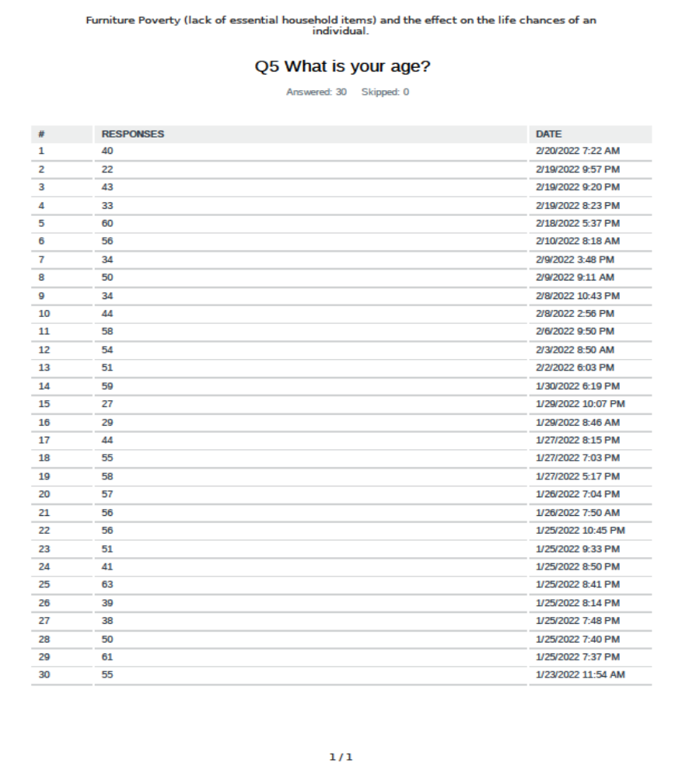

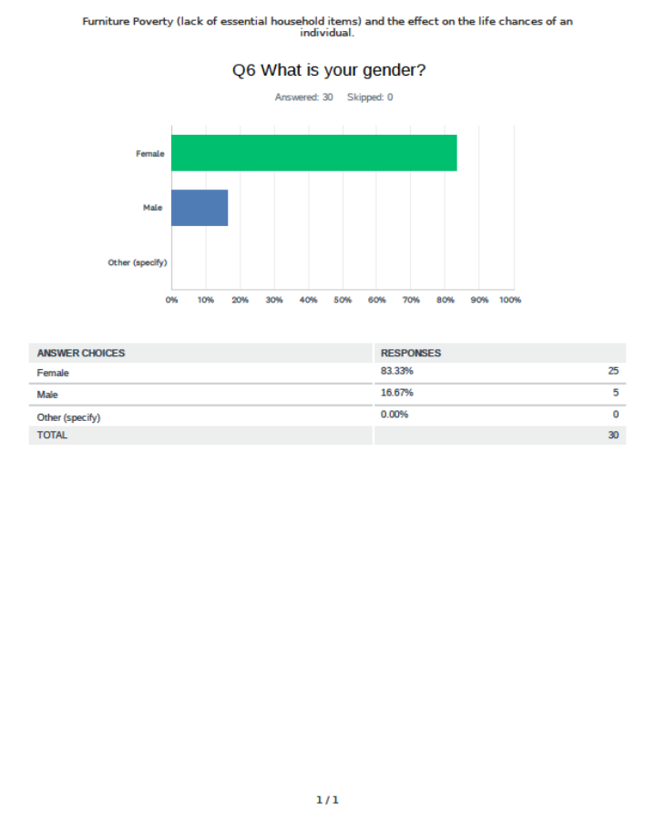

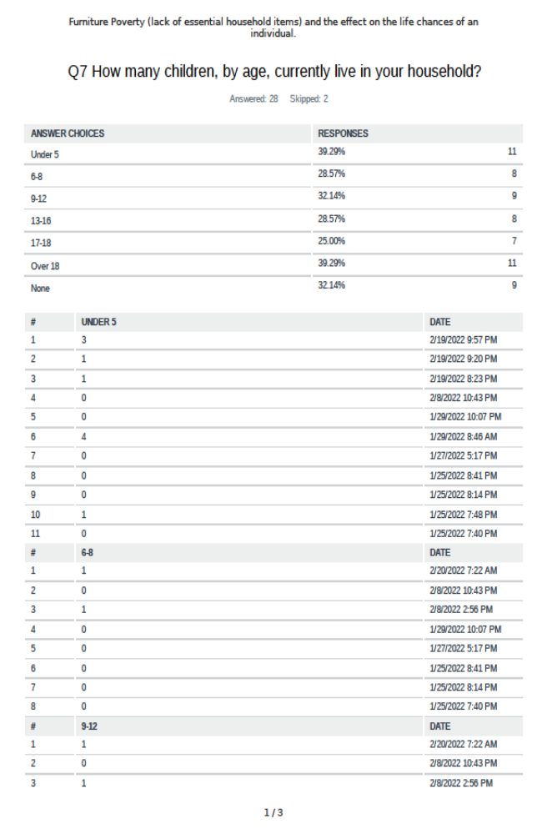

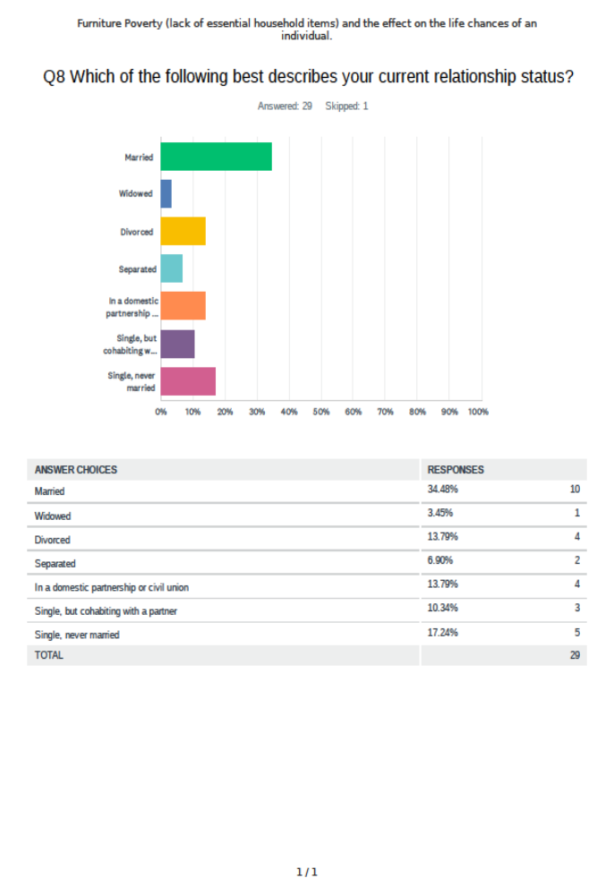
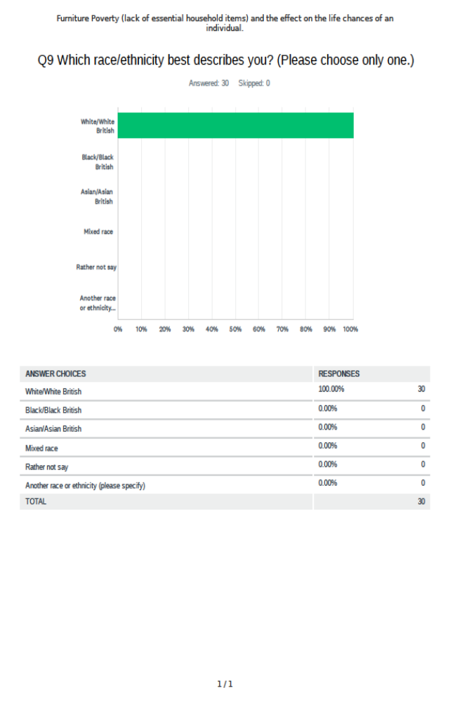

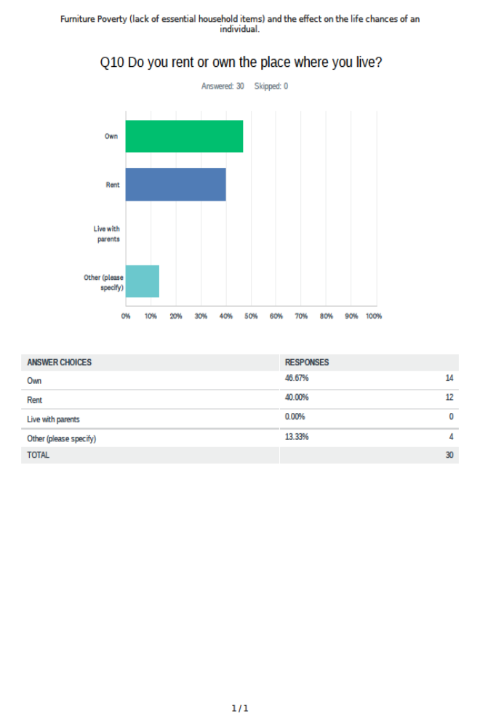

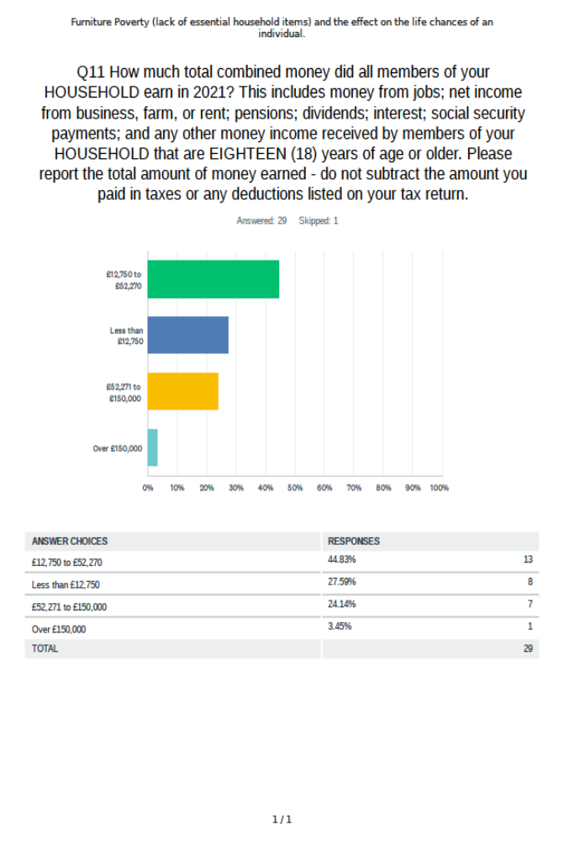
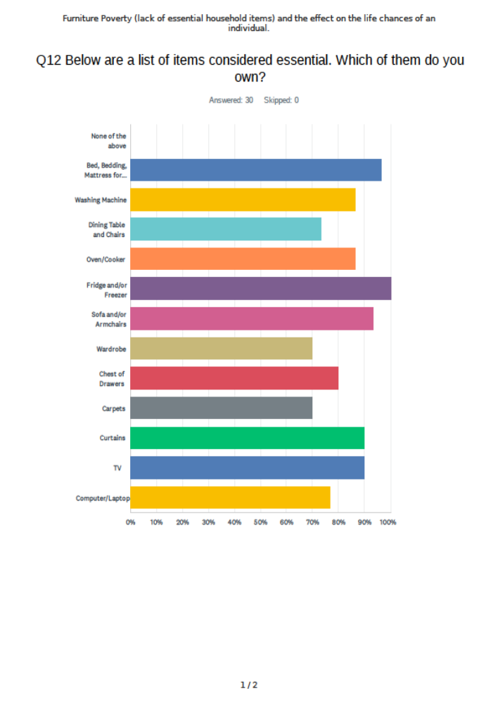

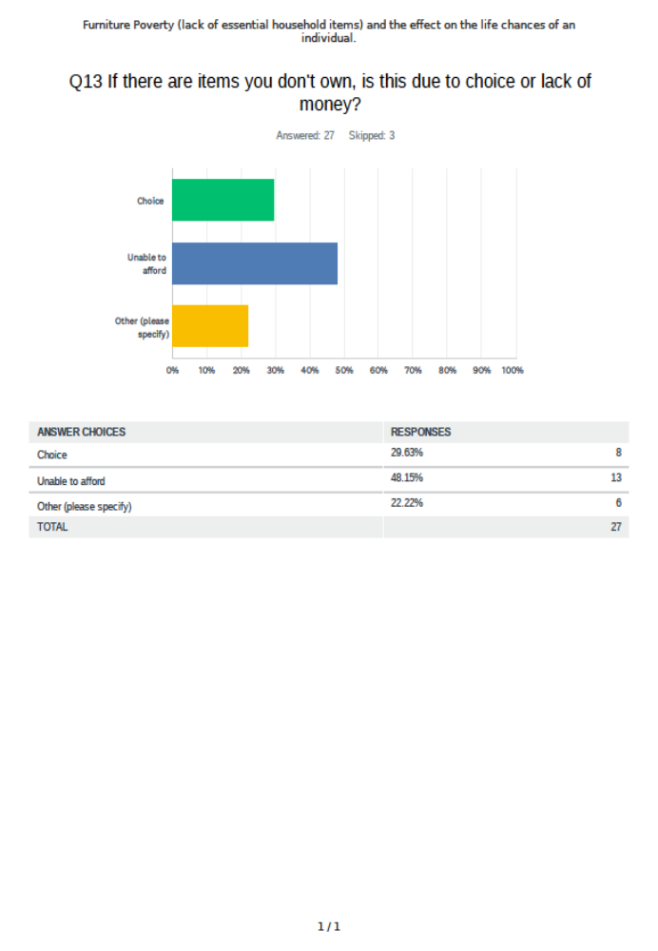

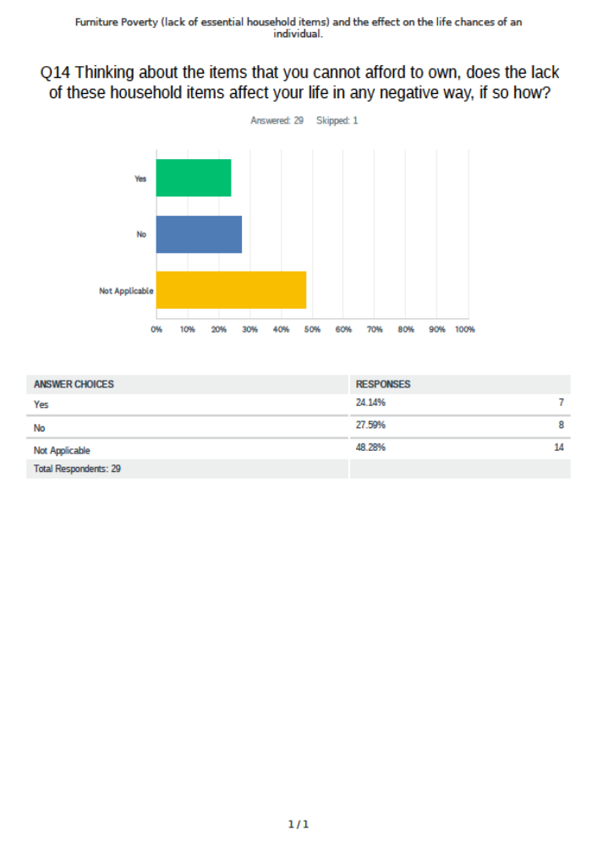
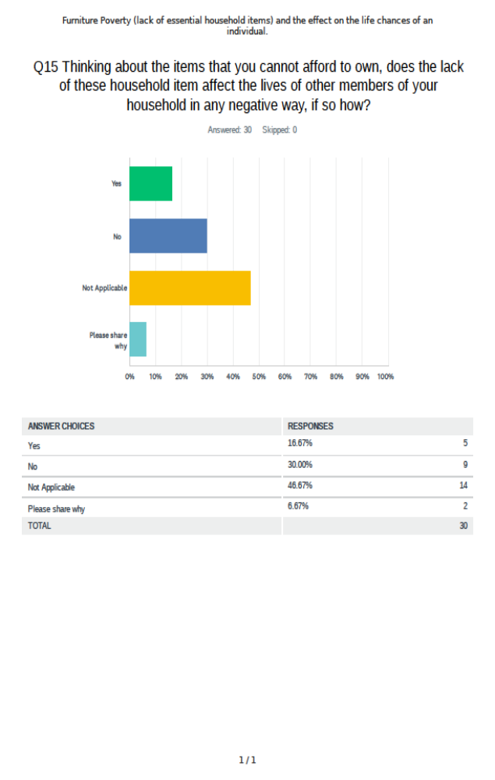

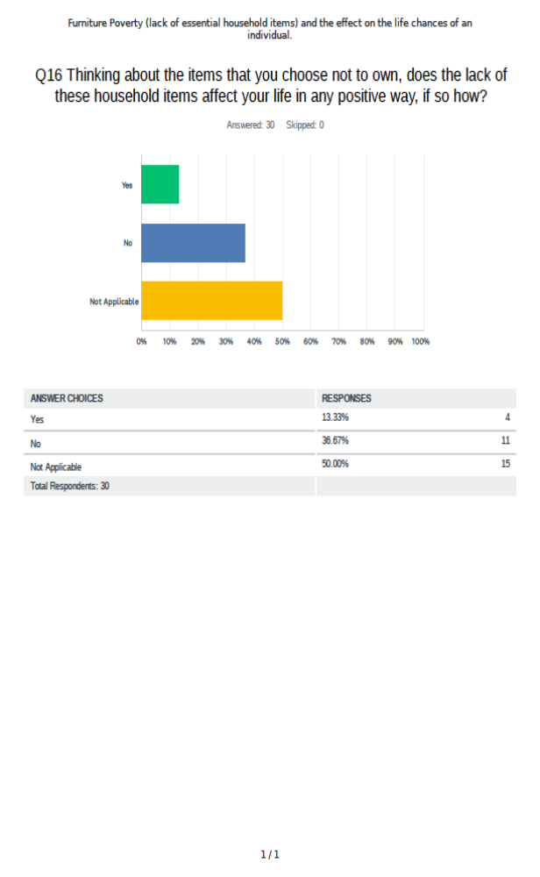

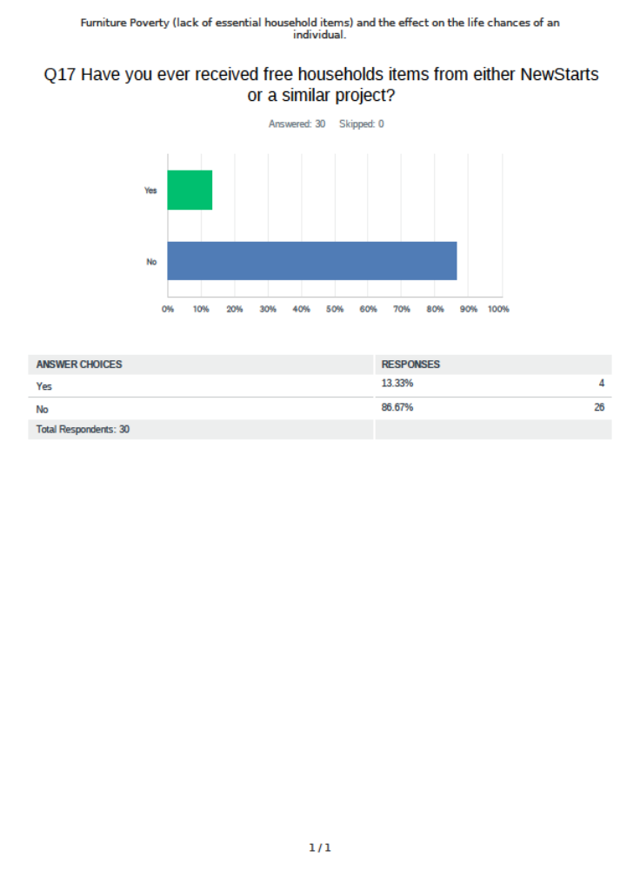

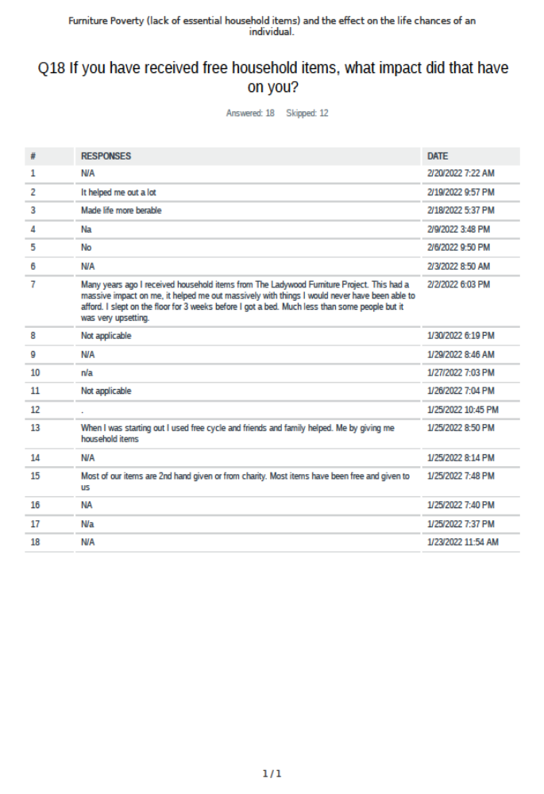

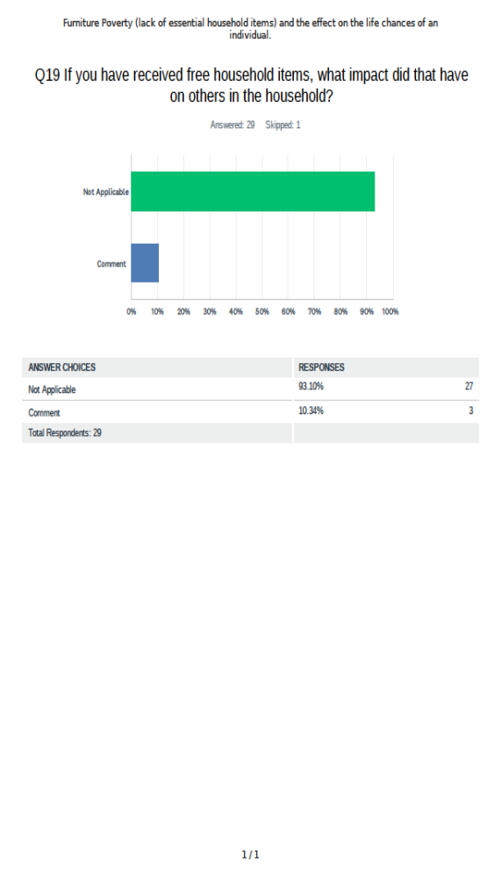

Appendix 3
Telephone Survey Results
Demographics
Age
Under 16 | 17-25 | 25-40 | 41-50 | 51-64 | 65+
0 | 2 | 0 | 2 | 1 | 0
Gender
M | F | Non-binary | Prefer not to say
1 | 4 | 0 | 0
Membership of household by age
Under 16 | 17-25 | 26-40 | 41-50 | 51-64 | 65+
8 | 2 |  | 3 | 2
Ethnicity
White British | Pakistani | Chinese
3 | 1 | 1
Ownership of items
Item | Owned
Beds, Bedding, mattresses | 0
washing machine | 3
Dining table and chairs | 3
Oven/cooker | 3
Fridge and/or Freezer | 3
Sofa and/or armchairs(s) | 3
Wardrobe | 3
Chest of drawers | 3
Carpets | 3
Curtains | 3
TV | 3
Laptop/Computer | 2

Question regarding income – When asked telephone respondents were unsure although all were receiving social security benefits
When asked about ownership all telephone respondents stated the lack of items was due to affordability.
Does the lack of items have any impact on either you or members of your family?
- We were all tired especially the children. It also caused pain sleeping on the floor
- Not having a bed affected our sleep patterns and my son has ADHD, so that just made that worse. I was always searching through black bags because that’s the only way I could keep them clean after they had been washed. I didn't invite anyone round because there wasn't anywhere to sit for me and my son, let alone anyone else and it was embarrassing. It was really exhausting
- We were really very frightened about moving but having the bed made it easier
- I'm not really sure how it affected me. I found it difficult to sleep and I was frightened that I would be evicted because I didn't have any furniture in the house
- This response was from the support worker as the recipient was unable to answer
When I visited this tenant for the first time with her social worker before the furniture and white goods had been delivered, she was not in a good place mentally. The flat was a depressive place, even though it was a building under 12 months old. Bare flooring and empty rooms did not help her wellbeing. She did not feel safe or settled and it was not good to be cooped up in just one room day and night.
If you received free items from NewStarts or another project, what impact did that have?
- we still need more beds
- Having the items meant that my son could sleep better, which helps with his behaviour. I can dress my son quicker in the mornign and with less arguiing because I know ehere his cvlothes are and I'm not rummaging through bags. He used to get really angry when I couldn't find what he wanted to wear. Its nice having a sofa, because we can sit somewhere and now I feel I can invite friends round.
- Made the move easier
- Once I got the items, life seemed better and I felt secure in the house.
- Again this is the response from the support worker
For the first time in her life, she had a place to be proud of. She is now thriving. Still needing support from Social Services and myself but her flat is furnished to her requirements and she now has a place she can call home.

Appendix 4
Transcript of Interview with online survey respondent 17 – 10th February 2022
Using Second-hand furniture
MK: Okay, so what I'm just going to do is just chat to you about some of the responses that you provided in the online survey you completed. I've got your responses here from the survey. And really, I’m was just trying to find out more about your experiences of not having furniture, and some of the challenges that you might have found, or if you've worked with people in the past that haven't had furniture. Are you happy to do that? If you want to stop at any time please let me know.

Respondent 17: Yes. I’m happy.

MK: So really, sort of where you're coming from. You put in your responses that you lacked items. . So what sort of things?

Respondent 17: The things like beds, bedding mattress? Washing machines? Yes. Often fridge and sofas, chest drawers, wardrobes, carpets, curtains, TVs, computer, laptop. I've owned them. But not all of them are brand new. Lots of not quite new white goods, I guess.

MK: So why do you tend to have second-hand rather than brand new?

Respondent 17: I can't afford brand new, I can't justify the cost, haven't got the money to do it anyway. And the idea of recycling is good. I do like the idea of that. And it's coming off. I don't like it would be too long. But you've got a new something. If it's old, it's just there.

MK: So that's really interesting. So let's sort of look into that a little bit more.

Respondent 17: I like nice things. But I'm creative about how I go about how we take treat something. I've been in the position of being a single parent, or been in a position of struggling. And I'm still very careful now to look at my son who's living with his child.

MK: Right.

Respondent 17: So I'm still having to be careful trying to support him, though, I like my nice things. I'll read from Peter reinvented, Robert Weiss, and now I have to be creative.

MK: So actually, for you, there's the whole creative thing is really important, as well.

Respondent 17: If you look at it, like if I can make do and mend I will.

MK: That's interesting, because of course, for some people, having brand new is really important.

Respondent 17: But that's not me, I don't know, I'm embarrassed, of course, about brand new. I feel truly that, for you to be able to afford something brand new, is embarrassing.

MK: That’s intriguing. So for you being able to afford something brand new is embarrassing, it’s awkward.

Respondent 17: Yeah. So I've always, I've always managed, I'm not saying I'm taking the position today, that I did when I was married. I'm not saying I didn't have new things. But I like second-hand things. And I put my mark on it.

MK: So trying to think that through. So having second hand things for you is about creativity, it’s about putting your own character into the things that are around you?

Respondent 17: Yes there probably is.

MK: So thinking about that is there a sense of greater ownership if there’s been input by you.

Respondent 17: People come into my house and see it and say ‘Oh, that's nice. Where'd you get that from?’ I like that feeling that I've helped charity or get stuff on marketplace. Whenever I've bought stuff from here (NewStarts) for my son, when he was with his partner, it’s good stuff, I think I've got my sofa, my sofa from here, because my old one, which I was given, had had its day. And so just chuffed to bits, because I could never afford a nice new one. I wouldn't anyway, because my daughter comes around with the dogs and I'd be more precious probably like, whereas I can put a throw on it I am less precious than if it was new. I don't know if it's damaged in any way I would be more precious than I already am. So I do still treat it as new. But I'm not. It doesn't matter

MK: That's great, because there's a number of things that affect your creativity, about you being clear about your ownership. It's not the same as everybody else's. And these are really positive things you see. So that's really interesting, that perspective is positive. : I guess there's something about making others feel comfortable in your space, because you're not being as precious as you might be.
Respondent 17 If you haven't got to worry, there's a little mark on the table or something because I am a bit OCD. I would be putting a mat there, instead I’m like, yeah, yeah, and it doesn't really matter. Because it's loved, is already been pre-loved, so that’s fine.

MK: Yeah. So it's about creating that environment perhaps.

Respondent 17: Yeah, when my grandson comes round I’m not like oh, oh, watch your fingers and all that. This is home.

MK: So he can just be who he is in your space.
Respondent 17: Yeah. Most of the time, anyway.

MK: Have you ever had a point where you thought actually, I'd really like to I'm one of those. I don't have it. And that's perhaps any sort of negative effect.

Respondent 17: I don't know. I think I’ve accepted it. That’s how I am. I have my dressing table was my daughter's dressing table. And I did buy that brand new. That was brand new. But to make it my own, I rubbed it down because I don’t want to give it away, because it was a lot of money. And it was this was when I was married, and I could do such things. I rubbed it all down and I repainted it and, and it's got different knobs on it all sorts and like it to bits, but glass top on it to stop scratch marks on the paintwork to maintain it. And the only thing that is new is the bed, because I wanted one I could put things underneath it. So I couldn't access one another. I would have bought a new mattress anyway. Probably a mattress is the one thing I would want to buy new.

MK: Is there any particular reason for that?

Respondent 17: It’s because I don’t know what's happened on it before. It could happen on the sofa or anywhere else. A mattress/bed thing having said that, I have bought second-hand mattresses, a single one for my daughter when she was little. Yeah, that was when I was married. And so I was married then, but I was careful. And so she had that and the bedframe only went to a couple years ago.

MK: Okay, so that again, that's really interesting. So there are certain things that you prefer to have new?

Respondent 17: Yeah. Although I'm not saying I wouldn't, yeah, wouldn't refuse if I thought it was t super-duper but yeah.

MK: Can you pinpoint where you actually haven't had something and you've found it difficult to deal with.

Respondent 17: Probably not probably been lucky.

MK: Okay, that's fine.

Respondent 17: Saying quite good dealing without yeah. Thank God is at the end of the day. So I probably but having said that, my son was renting a house with his girlfriend at the time, with the child and I think I transferred my feelings to making sure they had a nice home. I searched for a second-hand cot for them and because money was tight, I got some cutlery to make the house a home. It’s what I would have done in my own home but transferred to him to make his home.

MK: So again, that's quite interesting. So did you feel that without those things, it wasn't quite a home? You wanted to help them? But had they expressed any sort of concerns about not having those things?
Respondent 17: I knew what they needed, I knew they needed a television stand. So I've got a television stand, it's a cabinet thing, really. I looked out for what they said they needed, really. And when I went there, and I saw stuff, and I did sort of ask them, and then I've looked search for second-hand stuff to help them out.
MK: And so did they express everything in those conversations with you about its horrible not having that thing or this?

Respondent 17: Yeah. Well it was more general in that life is a struggle, you know, affording the rent and the nappies and everything. Yeah, well, that's what it's like. Done that worn the t shirt, you're telling me? But now he's back home. So I can see that if he gets somewhere I'll be doing this again. Because his partner's got a flat that the little boy goes to, and then he comes to me. And so I have to have him in my room. My son sleeps on his own in his bedroom. You can't swing a cat in. So then I was looking out then for travel cots and pushchair and all the baby stuff. The little boys mum still got the cot and obviously that can't come to me. So we're going to think about what we do next. So yeah, history repeating itself in a way.

MK: So you sort of said about marketplace. Do you get free items from there sometimes?

Respondent 17: Sometimes? I have done, certain community groups that you can get some things from. I got some bedding, baby bedding from somebody was giving away the duvet cover and some covers for a baby that I didn't have to pay for.

MK: And how does that make you feel when you get it?

Respondent 17: Really satisfied?

MK: So that's a really good feeling.

Respondent 17: Gee, yeah. Yeah. Something nice. And that person’s done something nice as well. Giving it away. Yeah, it's not many people. Well, there are people that do give things. But I was really grateful. Because I wasn’t in a position to purchase it. It's helped me.

MK: So how old is the little one?

Respondent 17: He’s two in March.

MK: So I guess probably when you got the bedding for the little one there wasn’t much of a reaction or was there I don't know?

Respondent 17: wouldn't know the difference? And he doesn't know the backstory.

MK: What about your son? How does he feel about that? Or does he not express that?
Respondent 17: Well, he doesn't express it that way. I think he's he he's having such a rough time to think he's back with his mom and all that. But he will go searching. I think he appreciates when I go searching things. I've actually bought a couple of box storage boxes from here, for him to put his bits and pieces in. I think he's grateful for that. I brought him around here the one day because if he gets around to filling out the forms for housing, I said, well, you know, there's an idea of what you can actually get yourself but he's not proud. He's probably like me seen how I struggled and appreciates that things don’t have to be new. So he's quite happy with that whole thing, my daughters a bit the same. She'll go and do it. She'll buy. She will buy expensive second-hand furniture. We get it done up. Because she's, she's about to buy a house. So that's the change my son and daughter completely different scenarios but they are on the second-hand furniture train as well, I suppose. Well, on white goods, I’ve bought brand new, but wouldn't stop me from buying second-hand if I have to. But I used to work for Children's Services and that's interesting because I work with families that probably couldn't give a monkey's. So everybody is so different. I think you need your bits and bobs? Not even if it's minimal to make it a home.

Second part of interview from a professional perspective
MK: So when you worked for Children's Services, did you ever access our service of free furniture?

Respondent 17: We use boomerang use for food parcels

MK: Boomerang similar thing. Yeah. So for some of those families that you worked with, because you can talk to me as a professional as well, was there any effect on their lives

Respondent 17: Was there any effects on their lives? Some didn’t sound very grateful. Some were like, it’s second-hand. You think How ungrateful. So I'd be very creative and say well, you can repaint it. Do this and make it your own? Some were very grateful.

MK: So the ones that you worked with, before they had the furniture, was it having an effect on their life at all? Or were they just okay, even though I don’t have the furniture?

Respondent 17: That yeah, kind of. They wanted it. But they were, it was almost I can't say too fussy, because we all like to see what we got it even when I buy things. I have to like what I'm looking at to get it? Obviously. So I don't know. So it's very hard to answer.

MK: I just I'm just sort of thinking. So let's say the items that they didn't have, did it cause different behaviours for those families, or did it affect the way they lived family life because they didn't have something?

Respondent 17: I don't think it has necessarily had a massive impact. I know about one family worked closely with that I remember, I actually gave me some of my children's old bedding, like a matching set, thinking that would be really successful, because of something they said. And I was thinking the next time I'll go around she’ll have all the curtains up and it will look lovely, but it didn't happen. So I think they have a dream, but the reality of putting it together is hard for them. I can't explain. So they say this is what I'd like. But I don't know, whether they're saying what they're saying to make it sound better, because it's social services, to create a better impression, but the actual reality to put it together isn't there.

MK: So from that, you're sort of thinking that actually they're quite content with how they’re living, yet they portray some that isn’t content. So for some families, this might be true, in order to satisfy what they think are the expectations of other people and when that's provided, they can't deal with it. They can't actually deal with it, because actually, they are used to how they live and the way they live?

Respondent 17: Yeah.

MK: And do you think that's a generational thing, because their parents lived that way?

Respondent 17: Sometimes they don't know any different. It's almost overwhelming.

Mk: Okay, so that's quite interesting in itself, because is that difference? So for me, it's, there's sort of a bit in my head that says, there's poverty and there's poor. And, you know, for some people, they don't have much, but they're very contented that.

Respondent 17: Is there a difference?

MK: But for some they do have that expectation from society to have more.
Respondent 17: So which is probably seen on television and they've actually got it and then they don’t how to deal with it almost. We reflect on it. I probably didn't appreciate that at the time. It's looking back. And you think well, actually, we've told them they've got these targets to do. And we've enabled them by getting certain things but they're doing it to please not because of necessarily that's how they want to be. Who knows?

MK: But that’s quite interesting, because then that's a society saying that this is the standard you should have.

Respondent 17: Do you actually really need it? What do you really want a wardrobe you know, and have jumped it on the floor anyway? And actually, some people doesn't matter that you're rich or poor, or whatever live in complete mess, my mums one, she lives in complete chaos whereas I’m the other way around, you see, because that's how she is. Mum’s not naturally a tidy person drives me mad, but that's how it chooses to live. I can't tell her.

MK: Exactly. And that's really interesting because that's a societal pressure being applied to, to a, in this case, a particular family. So they said, Oh, yeah, yeah, I should make this this and this. You've provided this, this and this, and then they've gone off and then they've done nothing with it.
Respondent 17: Yeah. So let’s put it in the wardrobe, oh I don’t have any coat hangers. But we had another family I've worked with, and she couldn't organise herself, food wise and children and all we did was suggest you got a slow cooker, which she did. And that changed that kind of absolutely changed her life. Yeah, her ability to manage with the children, we gave her a few recipes. This is what you can do on a Monday to do mince and roast chicken etc. She did gave it we just gave her different things. You go to the supermarket and you can do the cheap aisle or whatever. Reduce and slow down so you can cook better. Use a slow cooker do this and cheaper probably than what you what you've been doing. You can turn it on in the morning and leave it, you haven't got to touch it or you can do at night, the night before and children are in bed.

MK: But as you say again, that's really interesting, because that's very simple.

Respondent 17: Small thing doesn't cost a huge amount and can make feeding a family of four children more economical. Then what they were doing meant there was no chips and fish fingers and sausages. You can do a lot of enabling people to do it really show people what to do. Some will embrace it some actually, that is, like I said before, they won't know.

MK: So one of the things obviously around, you know, is it the lack of essential items that causes the problem or is there a challenge to life chances before the lack of essential items and actually, you could give them a house full of furniture and be perfect and it still wouldn't change the life chances because there's a mentality around things That's really that that's really useful to be honest, because you know, you sort of think about things and you sort of think oh, no, that's gonna be the answer.

Respondent 17: We think we can go into this and make it perfect whatever. It might not be what they need.

MK: Yes it is. That's really useful. That's been really, really helpful.

Appendix 4 (cont)
Respondent 2 Interview Friday 11th February

MK: When you completed the online survey you indicated you would be happy to take part in further research. The purpose of this interview is to build on the answers provided in the online survey. The interview will be recorded. Are you happy to continue?

Respondent 2: Yes

MK: Just as background the project I'm doing is around furniture poverty and effect it has on people's lives. And so one of the things is, of course, that if people choose not to have things, does it affect their life differently to if people can't have something, so there's, there's a subtle difference between the two. And that's going to be used to develop a new strategy for the projects I work for, which is a furniture reuse project. So we take furniture, and we give it away. So about 400 households a year, we just give free furniture to. And that's quite often it's everything for house. So we paid to wardrobes, tables, sofas, cutlery, crockery, all sorts.

Respondent 2: So how do you raise money for that or do you just get paid for it?

MK: What happens is, we get given to us, so people drop it off to us, and we pick it up, we sell some of it, because obviously, it's a really costly cost the price to give away furniture, because you have to warehouses and things like that. So you have to have all of that in place. So that's basically where we are. And obviously your responses to the survey didn't tell me that you were in furniture, poverty at all. But there was I think it was one that you sort of said that you chose not to have things. And so that's, I think, a choice. And also, I'm also talking to professionals who might be working with people who don't have it don't have certain items, and I didn't know whether you're still at the job centre, and if so, whether people still came in, because I'm a bit out of the loop on some of those things. Whether people can come in and say I haven't got the money for this, I need to buy this.

Respondent 2: Unfortunately, that’s all gone now. Our hands are quite tied to get things that they need. We still do budgeting advances and change of cirs. It’s a quite tight when it comes to being able to help them get round. Sometimes, I think that the service centre are so remote, they're so removed from the, the front line, and then because then they would come into to me or another on the team. And, and I will go in and say, Well, I'm doing it. I'm giving you it, you know. So feel if you say it puts them back in to hardship as well with the repayment. But that has changed a little bit now, because they've gone up to 24 months with the advances. Yeah, so that does help. From my opinion, as the local authority taken over the crisis loans in the community care grants and all that kind of thing. Is that they're very judgmental on people. Again, I think because it's an online an online application, again, they're just removed from it. And unless, you know, really troubled families, you know, no one really there's no one really going into any one poll. Many more. And getting the visual their actual, just their circumstances from the point of view of the job centre. Do you see what I mean?

MK: Yes, because I put up on Facebook because I knew before crisis loans, there was this thing. In my head. I thought they were single payments.

Respondent 2: Yeah.. And that was before, before I worked for DWP. But what I used to take my son to, I used to live in Woolwich. And I used to take my son to a mother, mother and baby group or some group. And where we lived when we had our own house and everything, it was really the area of Woolwich was was quite a deprived area. And not so these mums were were not like me. Does that make sense? Yeah, they didn't have partners, they didn't own their own houses. They were living, like, on income support. And I helped a lot of them, get those single payments by writing the application for them. So that's how I knew about the single payments. Yeah. That's how I knew about it, that, you know, people they used to have visiting officers to go round. Obviously, to get to get a case visit, you must know this. To get a visiting officer to take on a visit, oh, my God. Jesus Christ, got a run, jump through so many holes. And it's almost impossible. You know, we have cases, where we tried to get a visit, in the last two years with how our department has been where eventually we managed to get the police to go round to somebody's house, and they found them dead. No, I'm not kidding you. I'm not, you know, that's how bad it's been. I've had cases where you know that people refer to me, I get a lot of mental health cases referred to me. A lot of resp 2 can you see this guy? something's not quite right with this or something, you know. I get a lot of the alcohol dependency as well. I had this older man he was, so something didn’t sit right with me. Do you know what I mean? It was just an alarm bell going off in my head. This isn't right, what he was telling me. So I said to him, I said, I want you to come back in next week, like a safety net, really. And I kept this for about five or six weeks. I didn't really have the time to do it. But I did it. Yeah. And when I got like gradually broke down the barriers with him. And then I said to him, I said xxxx, how things going, you know, you've lost your bank card, you've lost your phone. You've lost your money. I said, why are all these things happening to you, xxxxx, He went I don’t know. And I just said to him, I said, I'll tell you why they're happening to you. Because you've got someone living in your house, who shouldn't be there. And he just looked at me. And he was crying. He almost cried. And I said that you're going to tell me what's going on. And then he just started telling me and I said, okay, and he said, You're going to help me out aren’t you. I'm going to help you don't worry, I'm going to help you. So as soon as his back was turned I was on the phone to the police. They raided his place that night put him in a place of safety and got got the people out. obviously cuckooing and all that kind of thing. He’s back in the area now and they look into places and sheltered housing. But you've got to have that intuition. This is not right, something's not right here.

MK: So, as you said like this quite often it's the main and we find that we get a lot of men referred to us. So older single mean, there's been a relationship breakdown and they're needing furniture. Do they ever sort of discuss with you what effect is having on their life at all, if they haven't got items even if it's really tiny little things,

Respondent 2: not in, not in the same way that they do remember when we all work together on the frontline, yeah. When we had those conversations when they were coming in for those things, and the more genuine ones would that very few now will come in and, and give us that information. Certainly not to ask for the people we have working for us now has not got a clue about poverty, social inclusion, all of those things, they just, it's just not, not in, you know, it doesn't affect them. So, that's it. They're there just to move someone into work. You know, whether they're ready for work or not, it's another thing about Universal Credit, the taking away all the easements, all the tools that advisors had to help someone so you come to me, and you know, And you've come to me, you've just been housed. So straight away, I will put you on 13 week easements you're you're there to get yourself like, sorted. overcome some of them barriers, like we say, even if it is furniture, poverty, let's get this sorted out. You need your children. You know, you have those conversations, all that is just been stripped back now. And our conversations for advisors, are you going to look for work? How many jobs have you applied for? I'm sending them to work and health programme I'm sending you to restart. We're not adding them in proper conversations with staff, our customers anymore. And I've heard through the grapevine that some of the states have not even got front attached anymore. So there's no walking.

MK: Well, I know, I know, the job centres in our area are doing a one to one but it's it's it's timed interview is definitely timed interview, they won't. Yeah, they weren't accepted for somebody just wandering in off the street is literally you've got an appointment, be there at the appointment time. If you're not there at the appointment time, then you're in trouble.

Respondent 2: Yes, yeah. But even you know, like your front of house was someone walks in with their, you know, they don't know how to claim, they don't know how to do anything like that. All that's being removed. It hasn't happened in Woolwichyet. But it certainly hasn't been vexing. Hey, so I've been told. And it's just a matter of time, really. And I mean, when you I mean, the demographics are fixed away from religion totally different. You know, you still got all your hardcore deprived areas. You know, they can dress really just as much as they like with their fancy apartment. And you know, all of that, but it's still there. It's, you know, it's still there its glaringly obvious, it's there. The minute you drive into the into the area every morning, you just see it. But I don't Yeah, it's sad. Sad that you can't do anything to help people. And what I find is when you do you know, you've got like, why is that person doing that? Why are they not doing a work session? If you were someone? I'd say, you know, I think it's gone from us. It's just, I mean, we used to have CAB advisors in our office that stopped now. They're no longer allowed. And I think the CAB was closing down, and it's all online. And if people can't get online you know, what did they do? Where did they go?
MK: Yeah, I mean, I, I do have some issues with the whole thing of moving online because I, you know, I think there are some challenges around that. I think there are some real challenges around that people don't know how to get online and even if they know the basics, what you find is that you know, the forms are quite difficult. to do online, there's not a video that says, you need to do this and you need to do that, you know, which would actually help. That would help a little video next to it that shows you what to do. None of that really exists for a lot of stuff. So from your perspective, really, I guess so the time is limited, so you can't really talk to people don't come in and discuss with you what the real issues are.
Respondent 2: I am a bit of a maverick. And I don't care because I think organisations need people that work outside the box. Yeah. They need someone to say hang on a minute. Now that ain't right. So why not right there. And there's so fit, like, in the job centre. So there's so few people that have got that that can do that the amount of times I get called on for mental health case. Army veteran young young person care leaver, I can't do either done YP’s for years and years and years. But every now and again, it's like and can you can you say can you come help me with this? You know what, I am going to be there for much longer so I don't know what's going to happen.

MK: Well, I think that's the problem. So so the ones like the care leavers and the ones with the mental health issues, what sort of the mental health issues was sitting behind? I guess it just depends on on the circumstances. But are there any sort of general things that sit behind those sort of mental health problems that you can sort of think of

Respondent 2: varies really you know, there how how a raft of triggers a trauma or breakdown reaching a point where you you have nothing for so long in the physical sense that it's now affecting you in a mental sense, as well, you know, take start taking away your, your confidence, your self esteem go. And then before you know it, you're you're on that road, you know, and it's so hard to pull someone back from that

MK: with the care leavers what their sort of biggest challenges other than trying to get some benefit in come across.

Respondent 2: I've only worked with a few young people over the last year or so. What family lots of young people is they're not prepared to look at themselves. They're not prepared to just because I see something on the front of a magazine you know, like, girls come in, and they'll say, Oh, I need this for the baby or I need that for the baby. And you know, I'll say to them, I'm straight with them. I go Yeah, but you've got your nails done. Yeah, your lashes. So you know what you spending your money on. And, and I think with lots of young people, I started as parents not parenting skills I found as missing skills become a crook. No actor. Okay, now, we don't know, anything, Marion, those things are going out the window.

MK: I mean, it's not just, you know, often I so often with the groups that I work with some of the young young people's groups, they talk about life skills, and Oh, yeah. But actually, it's more than that. It's actually it's not life skills. It's living skills, isn't it is actually being able to function as a human being? . Other than breathing in and out. Which is really interesting, actually, because I think we're down beyond something that is, it is teachable, but actually if there is So much that needs to be taught to young person, where on earth do you start?
Respondent 2: And it's not necessarily care leavers. This this young people generally don't people in general. I mean, my daughter's partner, hey, he's care later I would never put Stephanie with this guy in a million years. I mean, not that Stephanie was like, top of the shot, because she's not by any stretch of the imagination. But she failed every single GCSE that she took. And, you know, me and Martin were separated. We were. And so we took every single every everything away from her, we set up, we closed up. If you want to go mobile phone check to get part time job and check to pay the contract on it. Every single thing was taken away from us. Until she learned a lesson by it. And it was tough love it really was about she went and got a job. In next. A weekend job. Yeah. I can still remember may Martin had to go to Northwest Kent College. We were interviewed. Because she wanted a place there. So they wanted to see us because she was so bad. And which gave her assurance that we would get her out she wouldn't she would attain. We've got managed to get her into that. We thought she was going to do health and social care. She resat all her exams, we made her do that. And then she decided not I want to do a legal secretarial code. So at this point, me and Martin are looking at each other thinking, what are we going to do with? You know, that film was what shall we do with Kevin ? It was like, What should we do with Stephanie? You know? You know, she's got these course. She said about wanting to do some kind of work experience or something. And so he probably knew during that we may, I said, I'll come out to what you wanted. But she went and did it with my sister in law, who worked for training provider didn't really have any work for but so got sitting down, and she just did a mail shot to loads of different solicitors and lawyers, law companies and whatever looking for Virginia clerk, whatever. Got down to the last two, on the you know, yeah, last two being interviewed. And she got this job. And it changed her, completely. From there, she went on to a good few years. And then she went out to Australia and worked for an Australian barrister. And she did that freelance. And then she worked at different solicitors or law firms in Sydney. And then came back she was back here less than six weeks. And she joins an American Law Firm, dealing in corporate law, which wasn't really she understood but the money was excellent. But itself another apartment, our friend heather grey, I mean, don't get me wrong. We helped her. Yeah, you know, so she did us behind that as a, you know, take paid the deposit on the flat and things you know, or things like that, which some kids haven't got on that as well. Lots of kids haven't got that thing. And then from there, the guy she worked for joined another company and said, Will you come with me? For an extra 15 grand a year? She said yeah. So she's living in Greenwich. She's got a two bedroom apartment overlooks the whole of the London skyline. It's really lovely. Half a million pounds, but at the moment it's not worth any because of the timing, you know, it just goes to show that was a kid that didn't have a parent behind that that kid would be where they were. Yeah, you know, a lot of it is like, you know, the parenting, and even now, both mine know that we've got a look at them one way, and they just know.

MK: I mean, it's interesting what you say because I was talking to another person. That's taken part. And interestingly, they, they'd worked with a family, and they, the family didn't have any bedding for the children. So they’d given them bedding for the children, including matching curtains and everything. And so the parent was very, very happy to receive it. It was really pleased. But never put it up. Never put the bedding on the bed and never put the curtains up. But it was really interesting. You said it was almost like, she really wanted it. She got it, then didn't know what to do next. Yeah. And it's, it's almost like it's that, but that whole thing. So yeah, because we were just sort of thinking about, you know, we provide the furniture, because that's what we do, we provide the furniture free of charge to people that don't have it. And there is an assumption that people are struggling if they don't have it. But then if we're giving it and then they don't know what to do with it. In my head to someone gives you furniture or whatever, you're just gonna use it. But they started to raise another problem in my head, which was, right. Okay, so if people get in and don't know what to do with it, or how to use it, or how to make it, how you lay or all those things. Actually, we're not resolving the situation particularly. We're just putting more stuff in their house. Which is an interesting concept. We're just putting stuff in their house. They don't know what to do that stuff. But and you say some of the things, so what you're saying now about them, you know, they just don't have that ability, other than to breathe in and out and to get their nails done? Because that's what they see they should be having done.

Respondent 2: . The actual the actual parents, you know, you get with the women that come the girls come in with their, with their kids, and that the kids running around the room, and they're just sitting there, like, you know,. It I think if somebody has not had something, someone has come from a deprived childhood, gone into deprived adolescence moved into as a as a young adult it is like I don't know what to do with it. And also, do I really need that? Because I've never had that before?

MK: Yeah. And so for us, all of our, all of our referrals are done through professionals. So, you know, a bit like the old visiting officer would go into a home, they'd have a conversation with someone. Normally that conversation will be, oh, I need this, this and this. And I'm just wondering how many of our conversations that are happening now are you need this? You need this, you need this, but as you say, if not had it? Do they know what to do with it when they get it? and I think that's, that could be the generational thing. I mean, you know, when we were at the job centre or the benefits agencies, it was in those delightful days. You know, we had the children and grandchildren of people who've been on benefits and I suspect their children and their grandchildren. Some of those families will still be on benefit. So that's probably four or five generations.

Respondent 2: absolutely , the same names coming up again and again.

Mk: Well thank you for your input. So I was thinking that not having furniture affected lives,but now I’m thinking maybe giving stuff is also a problem if people don’t know what to do with it. Also the affect of providing furniture over the longer term. Will it happen again?

Respondent 2: of course it will. Professional organisations are having stripped away. There’s no funding for that and so people don’t get support. My daughter had her baby Christmas Eve, by caesarean, and I picked her up Christmas afternoon. No one came to see her. We saw her boxing day and the baby was jaundiced. No one, no health visitors, midwives came round to see her. My daughter was fortunate she had people who helped her. She has to travel several miles to see her health visitor and she doesn’t have a car. It’s like that with all the support services. There’s just nothing and no one to provide support, so how are people meant to get on.

MK: It is interesting to understand the impact it has on lives. Well thank you for your input. The results will be used anonymously in the research.

Interview with Respondent 8 on 24th February 2022

MK: Thank you, Kirsty. Okay, so you answered the survey around the impact of furniture property on life and I just wanted to ask what your experience personally was, and whether you had any other experiences with other people.

Respondent 8: Well, personally, I am a single parent. Yeah, with three girls. And I've always been brought up to be very thrifty. I think that's the option. And so it was always if you can get something second-hand, you do. So your sound, you know, you know, because what they always say, what's one man's rubbish is another man's treasure, isn't it? And, and having, you know, I do come regularly get furniture from NewStarts and other charity shops as well. I know, sorry. But I think you can, a lot of the older furniture is made a lot better. And it's not flimsy, you can upcycle it. It's not and it's the traditions of passing sort of down as well. And I've passed that on to the girls as well, because they look for such charity shop treasures, as we always refer to them it’s new to you, yes, rather than, you know, second-hand or anything. And we were always brought up in a family because my brother's the eldest cousin, and I'm the only girl but my brother would get like a new anorak. And then several years later, in family photographs, you see the youngest cousin playing out in it. So it had lasted 10 to 12 years and gone down in our lucky bags. So you pass the bags on and you were lucky because you got something nice out of it. And so we've always done that, and another reason is I can’t afford new furniture, you know, single parents, all the other bills going up. And it has to be done on a on a budget, you know, and if we can beg borrow or, you know, have charity, you know, it helps both ways because it helps the charity here. And it helps us at home, you know, so we bring, and often take more back of what we bring. And so it's a win win situation that you're, you're getting stuff off me and you know, we're getting things that are true. And I always instil that in at work as well, you know, work for Age UK now. Set up dementia meeting centres. So the majority of my resources are all from charity shops, if the older games, they all items because of the age group that I work with. We do reminiscence and they enjoy any anything that stimulates the brain. So the drafts Ludo, Domino's, scrap all cars, and then in the summer, and I had some students, 16 year olds that hadn't gone to places because of COVID for work experience, they're came and volunteered with me. And the old people teaching them the older games, and they were teaching older people the newer game, Because kids nowadays are just always on the machines up but they wouldn't think of sitting and sit around and play dominoes or cards, scrabble outs, the kids spelling cards, adding up, you know, scrabble for the math. And also it's that passing down of history as well that the old people was telling the youngsters about the times in the war and how they make do and mend because it's a very throwaway society I think at the moment that you know I'm guilty myself I don't darn socks, I will throw them out whereas you know, I have got a bodkin in my reminiscence box for them and because that's what they did you know you up to in those days I think we're lucky in some ways that the rather cheap shops in town land this on bargains B&M and things that you can get cheaper things. And, you know, I never ever go anywhere expensive now. It's always Wilko B&M that's my shopping. Whereas when I was on my own without the kids, I'd go to bounce expenses and next and you know, old shocks like that, but I just don't know it's always sale rail, or being passed on No dream now of going and spending 4050 quid on a top for me that will dispel issues for girls. So I think it's a mind-set as well as changed and I definitely have I'm more conscious now that do I need it? Can it go to the girls? you know we don't go out very often and I don’t very rarely drink I don’t smoke I have to think twice who wants to go to the cinema you know because the girls could go with their friends rather than me go with my friends and it does it affects your mental health very much and you know suffer with depression. I've been going through a quite an acrimonious divorce for nearly seven years. And it's the justification of what I do. And the cost you know, we're always looking we’re members of the National Trust so we can go out for a cheap day out. Pick a kind of flask. So like yesterday, we went with a friend we went down to Western. Alright, yep. So you know, she got a flask. It's smarter to pack got a flask hot dogs. We've got coffee, we've got our chocolate, and it cost us petrol and ice cream and a fiver for the kids to go on the peer while we walk the dogs on the beach. You know, it was yes, we could have gone and found a cafe in that. But we had a flask of coffee. Yeah. And it was that survived to saved, you know, because then it pays your bills and they've had a lovely day at Weston Super Mare not cost us a lot. Yeah. And you know, I can't afford to go to Bear Grylls or you know, places like that. I just can't do it. But it gave them fresh air exercise. And it was. So you know, we have to we have to do all that. And that's really the only thing we've done this week for half term. And I haven't been on holiday for two or three years the girls been up to out my brothers for a weekend. They’ll go away with their dad. They’ve been with aunts and uncles for a week. But physically, I haven't been able to take them away for a week. Yes, I just can't afford it.

MK: I mean, I do think it's really interesting about our expectations. As a child, we went away once a year in the summer holidays, and that was it. There is a different expectation that most of them are holidays, actually. Even in the summer, if we didn't go away, we're days out. Like you say without say, you know, you know except for tea. We would have sandwiches. We didn't go into the cafe that was in the Science Museum. We didn't go into the will coffee shops around as much then but we didn't go into the cafe where we were. It was very much. You took your lunch with you and that's what you get.

Respondent 8: And if you're lucky you got an ice cream?

MK: Absolutely. at the seaside or at Canterbury. If you're at Canterbury because the same ice cream shop. There's a shop Canterbury, and there was one in Broadstairs. So, and we stayed with my great aunt, in the summer holiday, when I was a child, and my mum would do the cleaning, because they owned the hotel, and my dad would do the jobs that they need to do while we were there. So we stayed for several weeks, but yeah, so I think there is a different expectation around things.

Respondent 8: And I think that is a challenge to overcome. I think admitting it as well it that's the habit that I mean, up until what three years ago I worked in NHS I've been a nurse all my life and I've got up to a senior managers level. But the move the office to the back of us Aston university instead, so by the time because I was on the on the kids by the time I've got them to Breakfast Club. Then in the traffic, it took me two hours to get there. Yeah, we'll do then I'd have to leave at four to get back by six because the school closed. I couldn't get my work hours in. So I was working at the weekend to mop it up. And I was fully set up at home. But they just kept saying the job you're in its corporate job. You've got to be a corporate HQ. He can't work from home you can't hop desk, but I caught you know Yeah. And I gave them 11 Different options eventually of how I could work and do the job and then rejected them all I had hair char involved day of my union involved and they just wanted me out. I think I've done over those you know, few years I've gone on to comments and I was based when doing jobs near a home by but I always had to go back eventually when it went yeah. And but then as soon as the pandemic hit, they'll give everything laptops. So, they've got a family friendly policy, they've got a flexible working policy, and they just wouldn't budge on it. And I just felt it was time for me to go. And I have basically I've have my salary books, it's a lot more easy with the girls, it's less stress, I'm a lot happier. But are they not to apply for benefits, which I've never done before. And I've got used to it now when I first did it, it was I shouldn't do in this, you know, we're both having half my salary. I can't pay the kids. No, no. And, you know, so I do get I get Universal Credit, I get that some maintenance off the dad. But I've just had to accept handouts, as it's classed and I'm very, very lucky that I've got a couple of friends that already never see a staff but I would also do the same for anybody else that I might not be able to go out from it would come up to you know, and we do it that way. And when I was single before I had children years ago, I have single friends and they're like well come to me for tea, you bring the pudding I'll do the main and then the following week would swap off and that was because we couldn't afford to go out for tea and it was company because I find that as well it's very isolating you know if you know a few that might omit for instance I've been in the house 21 years and a decorated when I first got there and gradually it's it's become that it needed decorating. I had a water leak so I had to take plaster off the wall. But I didn't have the money to get the work done. Yeah. So I've lived with you know, bare brick on the wall for four or five years. You know, marks from the kids, you know, things that need to do in and although my dad's up in Yorkshire, you need to get this done and I’ve said, because I can't I haven't got money. So they've actually started seeing the light in the last 12 months because I hit real rock bottom. And they've come down and they've decorated and I feel a lot better now. My mood has come back. Because I think as well you get very blinkered that, you know, you can't do it, so you just have to accept it, and you don't see it anymore. But you know, the girls have commented, you know, a few times I suppose a tip and friends always say it's a tip. Well, you live there as well. So you need to tidy up as well. But I think I just got overwhelmed, but if I did one room, it was a bit like a spring clean rather than just dust and a hoover. And then while I've done that the girls have trashed another room and then you do that room and they've gone and done something else to know you know, not being malicious but just life for three young children playing with toys and things. And so you know, it has to be tough but I am slowly getting there. We bought a sofa from here and I mean we've had that two or three years now my friends just asked me Do you want our syrup because we're getting a new one so what she's passing that on to us so again, it'll brighten the room up but I just can't afford anything you know, we just have to look for second-hand or doing without, it's I think.

MK: So when you're doing without stuff does that affect you? Particularly, especially if it's furniture?
Respondent 8: Yeah, I mean you know, I do the best you know, you wash the covers, I mean having kids there's no point being brand new. Because they always spill something or a sticky or you know the you know, slime that they've made on it and things I would never buy brand new with your children anyhow, and we've had a dog before we've got cat so I won't buy brand new because the likely to ruin any. I mean for instance the before Christmas, I suddenly wrote my car off. and it was 13 years old. And my driver's window didn't work. The top of the gear stick could come off. The CD player didn't work but they were all things that didn't affect the driving and couldn't afford to get them the mandate and then it just before Christmas somebody said in a cow and all downside in the car. They said it would cost too much to really mend it. So they were a car which is all very well and good. Gave me a decent amount more than I thought because of the car prices at the moment. But to go and get the effect of use that money to buy a car same old about to get an even older car. So I've had to lay out money to get a newer car. So I've gone from a seven seater to a fiesta... Which then has the knock on effect that I work out of my car because I go to five different venues in my work. So the back shelf have to come out because I get everything in the boot on the backseat, then I've been used to for 13 years, having seven seats. So you know, for going off for can take extra friends, we've got brownies, we've got equipment for camping and stuff. Whereas now it's like, well, I can't, because I've only got five seats. So that affects and then you feel guilty that a parent has to then take their kid to Redditch to meet you when you're driving there because I just can't physically get in the car, you know? And, and then that's cost me an extra 4000 pounds of what I don't have. So it's added on to the bill of what I owe me Dad, which has all stressed you know. There's no way I'm going to pay off everything I owe before he dies. You know you like 52 a professional. And up to my eyeballs in debt. And you feel like shit.

MK: I mean, I think I think it's not an uncommon thing. And I think that's the thing. I think it's not uncommon. I think there are lots of people who are caught in things caught in a trap.

Respondent 18: but I am lucky. I've got my own house. So at the end of the day, I've got a roof over here, we've got food in our bellies, so I don't have to go out, you know, I'm not stuck in a bed sit or in a hotel that you've got to get out.. But it's like, you know, got myself into a mess last year. So my stepmom has done me a spreadsheet. And every month, we go through it, and everything I've spent and know how much I've got for food and what you've got for petrol and, you know, kick things for the kids and everything. And by the time I've paid for everything and put money away for mot wear and tear on white goods and things. I've 22 pounds left for a month with three kids, which yes, that covers the petrol but there's no niceties there. No, you know, and I am looking at I'm not just on benefits. No, you know, and so, you know, we can stay at home and everything. But the next thing is I pay 120 pound a month for gas and electric at the moment. Come April. Yeah, what we're going to do. I mean, my friends sort of scoured all the girl compare sites in the last two weeks. And she paid 150 and she says the cheapest you can get 400 pounds.

MK: I have to say that just before Christmas, our tariffs came up. And we paid 90 pound a month. Yeah. I scoured British Gas was 4000 pounds a year. And our current supply was the cheapest at £170 per month... And it's about 50% on the electric and it's about 70% on the gas.

Respondent 18: that seems to be the split through. I mean, we're lucky because I've got a coal fire because it's an old house. And I mean, even now we're looking at that a mild winter I mean, I'm pretty frugal the heating goes off the you know the You know, the first of April. Don't go back on to the first of October. Well, it will be it comes off March and it couldn't go back on till November. And I am lucky because we've got open coal fire. I can set and I've been turned in heating off. And just like in the coal fire on an evening when it's been really cold. Most of the time that kids are dancing around in T shirts and shorts are not to say that put some pyjamas on put fluffy socks on, you know, get your dressing gown, you have to do your homework on your bed, and you do there. And if it's very, very cold, I will flick the heating for bait. But that's doing it now. I haven't got an extra 400 quid a month. And I think I think that's a concern. Its National Insurance is going to go up. And I think that people will start to die of hypothermia and starvation. I think we're going back to the Dark Ages. And this is wrong, though. It feels it feels that it's always been the case that benefits in particular are something that people have to know about... But nobody's going to help them know about it. And I think as well, a lot of I mean, I'm, you know, I'm pretty intelligent, you know, I'm a professional, I struggle, whether it's a bit of mental health, I am not the time because I work full time come back to the girls house, or it's the fact that that bit, because I'm overwhelmed. You know, these, you know, a lot of people that aren't as intelligent, haven't got access to the internet and everything. How are they? You know, there's no support there. You know, everybody needs a social worker.

MK: Well, yeah, and so one of the other pieces of what we're doing is communities, asset based community development. And we've got two community builders one in Catshill on one in Rubery. And their job effectively is to understand what's going on in the community, understand what the community wants to do, what it needs help with, a where they work community needs help, then we will intervene where it doesn't, we'll just let the community get on and do whatever they need. But it does go back to that you saying, Look, we're friends, and you know, you meet up for something and so have something to eat or whatever. But it is very much that going back to a time when everybody helped everybody else. And I don't think some of that's a bad thing. Coming around. Not a helpful scenario, especially when there are probably those who are do very well out there. Thanks very much. Yeah. Just sort of thing. Okay, that's, that's not really very helpful.

Respondent 8: I think it's a stigma as well, isn't it? Because although, I mean, I'm very astute with my Yorkshire head on. I always got six o'clock in Morrison's when it was introduced. I don't buy any meat full price. Yeah, if there isn't anything in the produce section, we have frozen, we've gone back to frozen food rather than fresh food. And because again, you know, it's the, it's the price. And so but my dad has said, Well inquire about the food bank. So I can still go on a limited budget and get food. Where is the bag is Sunday, that counts. But I don't know whether I'd be eligible but there's still that stigma. And they need to be able to provide for my family without handouts, not on handouts that I mean.
MK: Obviously, you know, we run the food banks here. If you do find yourself needing it, just bring cab they can fees vary. The council can send you through as well as a little bit. And we are actually thinking about moving to vouchers. So people want to come here and get a bag of food because I've got a, there's a fundamental problem with that is okay for an emergency moment? If people are continuously having to come here, we're telling them what to eat. Because effectively that we were doing this as well.

Respondent 8: And you don't know what their cooking facilities are, you know, if you're in a bedroom, you've only got a kettle, or you have to have pot noodles, and, you know, cuppa soups, whereas if you've got access to a microwave or a hot plate, and if you've got the gas and electric to warm anything,

MK: So. So there's a fundamental problem for us now, which is, we've seen that over the past two years, which is this whole supporting people we have supported people for two years. some people are really struggling. But we are very conscious that coming over the hill, or another group of people who up to now Yeah, but maybe from eight to one. And so please feel free to access us we are looking at whether or not we go to vouchers. We’ll probably have a selection.

Respondent 8: Then the idiots of the world will say oh, they're doing it because they get more businesses if you only give Morrison's or is there a monopoly there or I will have the selection?

MK: So people go to the place they feel most comfortable going to rather than and also he might be able to walk he might not be able to get a boss exactly tag say You know, it's okay given LD a little here. But if someone lives in Rubery, that's a waste of time because they thought they will have a Tesco and the Morrison’s

Respondent 8: I go to a lot of the different supermarkets because I always go straight for the reduced sections. You know, Sainsbury's is expensive. If you can only walk to the local shop Co Op is expensive. Coop is expensive, but it's got limited mobility. You can't carry anything. You're elderly, whatever, you got loads of little kiddies. And it might not be healthy. Because to try and actually eat healthily costs more?

MK: It does. I mean, I've had this again, I've had conversation with a few people who said to me, well, if they just cooked from scratch, it would be cheaper. And I really, you really think that's the truth. So you've got to have this and although they last longer, you still got to have in the first place. If you haven't got them yet, then you've got to buy them is then got to have all the ingredients and the gas and electric to cook it. Oh, yeah. It's not cheaper than having all the ingredients to make a pasta sauce is going to be more expensive than the one pound jar of pasta sauce. Yeah, I'm sorry, but it is.

Respondent 18: I have to think ahead. I have to put away £20 a week to save for the uniform. I think ahead, but not everyone can do it. The shop in Bromsgrove has a rail with second-hand
MK: we are working with them, they take the badged uniform and we have the unbadged.

Respondent 18: My daughter’s shoes have holes in them and bless her she has told the teacher that we can’t afford to get a new pair and so she is going to wear her black trainers until she leaves in May like the rest of the kids.

MK: well trainers are much more acceptable than they used to be. I’m not quite sure why the schools still have a thing with them. I meet lots of people in all sorts of walks of life and most of them where trainers. It’s quite acceptable to wear trainers with skirts and dresses.

Respondent 18: well it’s acceptable to wear ankle boots with tights now, whereas it never used to be:

MK: I wear trainers a lot of the time because I like them and they are comfortable. I wear trainers with skirt. They’re comfortable. I don’t see it’s the problem it used to be.

Respondent 18: Then they have to the Nike trainers, but when we were kids you used to have the supermarket plastic ones. We couldn’t afford the expensive ones.

MK: well the interesting thing about Nike ones is that there are some good sites, where they say when the sales are on and you get the trainers for £30 or so, especially in children’s sizes. A lot of women wear children’s sizes

Respondent 18: we’re all a size 5 and xxxx has shrunk since she lost weight. But that’s brought a different problem, because she needs to have a whole new wardrobe. And she has kept her blazer but her skirts has to be replaced.

MK: Well we’re back to life skill. She could have sewn the skirt.

Respondent 18: And then we’ve got prom. We can’t afford the cost of a dress. A friend has her army prom dresses. So xxxx is going to have a look and if necessary we will get it adjusted. And then the school have booked the prom a 20 minute drive away. I’ve told her I can’t afford to hire a limo. And she has said she will do her nails. And her friends will have the make-up etc.

MK: We had an idea of a prom preparation evening. Picking dresses, suits, how to do make-up and hair etc.

Respondent 18: When they go out they get all their stuff from Primark and the like. They do each other’s make-up. Not everyone has the facility. And then there’s the washing machines.

MK: Well that has come up before

Respondent 18: One of xxxx friends has an aroma and I’ve asked xxxx whether there is a problem. Maybe they don’t have a washing machine, or can’t afford a bar of soap.

MK: Well there’s the issue as well that we have moved from a bath once a week with good washes. Then suddenly we shower every day.

Respondent 18: And then what happens if their washing machine breaks. Our washing machine is outside and sometimes the pipes would freeze. So I would text my neighbours and one would say mines empty and I would take my washing to their house and the same is true if their washing machines weren’t working. Then there’s the whole thing about period poverty because they can’t afford the products. I buy reduced. There’s a stigma around poverty.

MK: Well I think there is a difference between being poor and being in poverty. Many people are poor but they are content. Others don’t. And I think that it is that group that are in poverty. If they are not able to manage then everyone knows. It also goes back centuries to the rhetoric that those who are in poverty they have made bad choices and/or are lazy. This is not true

Respondent 18: Well look at me I’m a professional and I have thought about doing extra shifts as a nurse, but it’s just not worth it. I loose so much and to be honest after a week at work I am knackered. I just can’t do it.

MK: No it’s difficult. Well I want to thank you for your input into the research. It’s been great chatting to you.

Respondent 18: You’re welcome.

Appendix 5
Case Study
Case Study 1
I am a young man in my 20s. I was up until recently employed. I worked hard and played hard. I often drank a lot and took recreational drugs. About 6 months ago my ex-girlfriend contacted me and said that she was going to put our 2 year old daughter into care unless I took her. I decided to look after my daughter. I lived in a local hostel so me and my daughter shared the room. I had to stop work to look after her and the drinking and drug taking also had to stop although I still sometimes have a can of beer. Because of the sudden change it has taken me quite some time to sort out my benefits and up till recently I have been managing on my single persons allowance while the child tax credit and child benefit were sorted out. Looking after my daughter has been much harder than any job I have ever had. Sometimes I have really struggled with money and the food bags from NewStarts have really made a difference. When I recently was given the tenancy of a flat, NewStarts were able to provide me with all the necessary furniture to set up home. I am sure I wouldn't have managed without them and I am grateful that they have helped me to look after my daughter. I have now lost custody of my daughter, who is living with her mother. I see her as often as I can, but that can be difficult because she is living in Wales. I am now looking for employment and due to a number of circumstances have had to receive further food parcels. The staff and volunteers at NewStarts are always friendly and don’t make me feel inferior in any way. They always welcome me and ask about my life and how things are going.
I haven’t had to use NewStarts for a while, but things have gone a bit wrong again and I’ve been using drugs and drinking and so I have had to have some food parcels over the past couple of weeks. I’ve met someone new and we are trying to make a go of it, gonna try and stop taking drugs, and so we have been referred for furniture. She has children and I have my daughter and we have another child on the way. I’m going to try and get some work or if not maybe go self-employed. Not sure what I’ll do but I’ll have a go at anything.
I managed to set up my little business, but I had only been going six months when COVID started and everything went into lockdown. At least this time I’m just needing some help with food and not furniture. I’m trying to stay positive.

Comments
This young man has been known to NewStarts since 2013. This case study is a summary of our interactions with him and as can be seen, whilst he was given furniture in 2013, a number of years later, he was referred again for furniture. This is not unusual and is usually because of a combination of issues including poor mental health, difficulty managing relationships, chaotic lifestyles, drugs and/alcohol.

